DEVELOPER GUIDE
Alpine Ascents
Mountaineering Information Website
Project Title: Alpine Ascents eProject
Documentation: Developer Guide
Group: D
Course: CPISM
Batch Code: 2606E2
Team Member | Student ID
Areesha Junaid | Student1733481
Muhammad Huzaifa Iqbal | Student1733900
Yashfeen Fatima | Student1733472
Zakria Khan | Student1734513

Abstract
Alpine Ascents is a responsive, front-end-only website that presents detailed and organised information about mountaineering. It has 14 pages: a home page and 13 inner pages covering About Us, the history of the sport, types and styles of climbing, techniques, world records, safety guidelines, mountain hazards, sheltering, a photo and video gallery, mountaineering clubs and camps, latest news, feedback and contact.
The website is built with HTML5, CSS3 and vanilla JavaScript, with no backend, framework or database. It uses one shared global stylesheet plus a stylesheet and a script for each page, a video hero banner on the home page, scroll-reveal animations, a welcome form that asks each new visitor for name, location, email and phone, a live ticker showing date, time and location (through the browser Geolocation API and OpenStreetMap Nominatim), and a visitor counter. Inner pages add filters, search, sortable tables, pop-ups, a lightbox, a safety checklist, a shelter booking form, an interactive clubs map (Leaflet) and validated contact and feedback forms. Everything the visitor enters is kept in the browser (localStorage and sessionStorage) and nothing is sent to a server.
This Developer Guide documents the purpose, requirements, technology, architecture, folder structure and implementation of the project, with page and source-code screenshots, flowcharts and data flow diagrams, so that any developer can understand, run and extend it.

Acknowledgement
We would like to thank our course instructor for guidance, feedback and support throughout the development of this project. We also thank our institute for providing the learning environment and resources, and our families and classmates for their encouragement.
Finally, we acknowledge the free resources used in the project, including Unsplash and Pexels photography, Google Fonts, the Leaflet map library, TopoJSON and Natural Earth country data, and OpenStreetMap Nominatim.
Group D, Batch 2606E2
Areesha Junaid · Muhammad Huzaifa Iqbal · Yashfeen Fatima · Zakria Khan

Table of Contents
Abstract 2
Acknowledgement 3
1. Introduction 6
1.1 Project Purpose 6
1.2 Project Scope 6
1.3 Development Objectives 6
2. Project Requirements 7
2.1 Hardware Requirements 7
2.2 Software Requirements 7
2.3 Browser Requirements 7
2.4 Development Environment 7
3. Technology Stack 8
4. Project Architecture 9
4.1 Layers 9
4.2 Data Storage in the Browser 9
5. Project Folder and File Structure 10
6. HTML Implementation 11
6.1 Document Head 11
6.2 Header and Navigation 11
6.3 Home Page Sections 11
6.4 Ticker and Footer 12
6.5 Accessibility Features 12
7. CSS Implementation 13
7.1 Global Styles 13
7.2 Page Stylesheets 13
7.3 Responsive Design 13
8. JavaScript Implementation 14
8.1 Shared Script (main.js) 14
8.2 Home Script (home.js) 14
8.3 Page Scripts 15
8.4 Browser APIs and Libraries 15
9. Website Pages Implementation with Source Code Screenshots 16
9.1 Home Page 16
9.2 About Us 18
9.3 History 19
9.4 Types and Styles 21
9.5 Techniques 22
9.6 Records 23
9.7 Safety Guidelines 25
9.8 Hazards 26
9.9 Sheltering 27
9.10 Gallery 29
9.11 Clubs and Camps 30
9.12 Latest News 32
9.13 Feedback 33
9.14 Contact Us 34
10. Diagrams (Flowcharts and Data Flow) 36
10.1 User Navigation Flowchart 36
10.2 Share Location Flowchart 37
10.3 Form Validation Flowchart 38
10.4 Data Flow Diagram: Level 0 39
10.5 Data Flow Diagram: Level 1 39
11. Future Scope 40
12. Conclusion 41

1. Introduction

1.1 Project Purpose
The purpose of Alpine Ascents is to provide a single, reliable and visually engaging place where beginners and enthusiasts can learn about mountaineering. Instead of searching across many sources, a visitor can read about the history of the sport, learn the essential techniques, understand the hazards, follow general safety guidelines, explore records, find mountaineering clubs on a world map and even request a shelter booking.

1.2 Project Scope
The project is a static, multi-page, front-end website of 14 HTML pages (index.html and 13 pages in the html folder).
In scope:
- A long, section-based home page with a video hero slider that introduces every major part of the site
- Dedicated pages for About Us, History, Types and Styles, Techniques, Records, Safety Guidelines, Hazards, Sheltering, Gallery, Clubs and Camps, Latest News, Feedback and Contact Us
- Consistent header, navigation, bottom ticker and footer on every page
- A welcome form that collects visitor details once per browser session
- Client-side features: dropdown menus, hero video slider, scroll animations, visitor counter, live date, time and location ticker, filters, search and sorting, pop-ups, lightbox, safety checklist, clubs map
- Form interfaces with validation (welcome, contact, feedback and shelter booking) whose entries are stored in the browser
Out of scope:
- Server-side code, databases and user accounts
- Real payment processing, real shelter reservations and delivery of messages by e-mail
- Live data feeds such as weather or avalanche bulletins

1.3 Development Objectives
- Build a professional, consistent and fully responsive website using only HTML, CSS and JavaScript.
- Present mountaineering content in a clear, well-organised structure that is easy to navigate.
- Use modern interface techniques such as video banners, reveal transitions, count-up numbers and hover effects to improve the experience.
- Apply the browser Geolocation API for location-aware content (ticker, forms and the clubs map).
- Follow accessibility good practices (semantic HTML, skip link, ARIA attributes, keyboard support, image alternative text, reduced-motion support).
- Keep the code clean, modular and easy to maintain, with one stylesheet and one script per page.

2. Project Requirements

2.1 Hardware Requirements
Component | Minimum | Recommended
Processor | Dual-core 2.0 GHz | Quad-core 2.5 GHz or higher
RAM | 4 GB | 8 GB or more
Storage | 500 MB free (project, images and videos) | 2 GB free
Display | 1366 × 768 (phones and tablets also supported) | 1920 × 1080
Internet | Required for fonts, online images, map libraries and location names | Broadband connection

2.2 Software Requirements
- Operating system: Windows 10 or later, macOS or Linux
- Code editor: Visual Studio Code (or any text editor)
- Recommended: Live Server extension for local testing over http:// (the Geolocation API and some features work best over HTTPS or localhost)
- Optional: Git for version control

2.3 Browser Requirements
Any modern browser with HTML5, CSS3 (Grid, Flexbox, custom properties), ES6 JavaScript, HTML5 video, localStorage / sessionStorage, IntersectionObserver and the Geolocation API: Google Chrome, Microsoft Edge, Mozilla Firefox, Safari and Opera (latest versions). Location features require the user to grant permission and an internet connection (for the place name lookup).

2.4 Development Environment
The project was developed in Visual Studio Code and tested in desktop and mobile browsers using the browser developer tools (responsive mode). No build tools, package managers or frameworks are required. Opening index.html in a browser is enough to run the site; an internet connection is needed for Google Fonts, Unsplash images and the clubs map.

3. Technology Stack
Layer | Technology | Usage in the Project
Structure | HTML5 | Semantic pages using header, nav, main, section, article, figure, details and footer
Styling | CSS3 | Flexbox, Grid, custom properties (:root variables), media queries, transitions and keyframe animations
Behaviour | JavaScript (ES6, vanilla) | Welcome form, navigation, hero slider, ticker, visitor count, reveal effects, filters, search, sorting, pop-ups, lightbox, checklist, forms
Typography | Google Fonts | DM Sans (body), Playfair Display (headings), Instrument Serif (logo)
Images | Local files and Unsplash | Local JPG and AVIF files in the images folder (gallery, hazards, sheltering); Unsplash photos loaded by URL for page banners and cards
Video | HTML5 video (MP4) | Hero banner slides on Home and Gallery; Gallery video cards (files in a videos folder)
Map | Leaflet 1.9.4, TopoJSON client, Natural Earth data | Interactive clubs map drawn from world-atlas country shapes (loaded from unpkg and jsDelivr)
Browser APIs | Geolocation, Fetch, IntersectionObserver, localStorage, sessionStorage, Permissions | Location in the ticker and forms, place-name lookup, scroll reveal, saving visitor data and entries
Web service | OpenStreetMap Nominatim | Reverse geocoding: converts coordinates into a City, Country name
Icons and logo | Inline SVG | Logo mark, visitor icon, ticker icons and footer icons
Tools | VS Code, Git | Development and version control

4. Project Architecture
Alpine Ascents follows a client-side, multi-page architecture. Every page is a static HTML document that links to the shared stylesheet and script plus its own page stylesheet and script. There is no server logic; all behaviour runs in the visitor’s browser.

4.1 Layers
- Presentation layer (HTML and CSS): page structure, the shared visual theme in css/style.css and one stylesheet per page (for example css/records.css).
- Behaviour layer (JavaScript): js/main.js runs on every page and handles the welcome form, navigation, ticker, visitor count, location, toast messages and animations. js/home.js handles the home hero slider. Every inner page has its own script (for example js/hazards.js) for its filters, pop-ups or forms.
- Content and media layer: text content written directly in the HTML, local images in images/, Unsplash photos loaded by URL, MP4 videos in a videos/ folder, and data arrays inside some scripts (the 16 clubs in clubs.js, the 11 hazard descriptions in hazards.js).
Shared components (skip link, header with logo and navigation, visitor box, bottom ticker and footer) are repeated with identical markup on every page so the site looks and behaves consistently. Each page body carries a class such as page-home or page-records so page-specific styling can be applied, and a data-root attribute (empty on the home page, ../ on inner pages) that records where the root folder is relative to the page. Scripts use window.AA, a small public object created by main.js (with $, $$, store, locate, toast and visitor), so that page scripts can reuse the shared helpers.

4.2 Data Storage in the Browser
No data leaves the browser. The following keys are used:
Key | Storage | Purpose
aa_visitor | localStorage | Visitor name, location, email, phone and coordinates saved from the welcome form or ticker; used to pre-fill the contact and booking forms
aa_visits | localStorage | Number of visits counted in this browser; shown in the visitor box (offset by a starting value)
aa_entered | sessionStorage | Set after the welcome form is submitted so it is not shown again in the same session
aa_counted | sessionStorage | Makes sure a visit is counted only once per session
aa_messages | localStorage | Contact form entries (array)
alpineAscentsFeedback | localStorage | Feedback form entries (array)
aa_bookings | localStorage | Shelter booking requests (array)
aa_checklist | localStorage | Ticked items of the pre-climb checklist

5. Project Folder and File Structure
Alpine_Ascents Group_D 2606E2/
├── index.html (Home page)
├── Alpine_Ascents_Developer_Guide.docx
├── Alpine Ascents User Guide.docx
├── css/
│ ├── style.css (Global styles shared by all pages)
│ ├── home.css (Home page)
│ └── about us / history / adventures / techniques / records /
│ safety / hazards / sheltering / gallery / clubs / news /
│ feedback / contact us .css (one stylesheet per page)
├── js/
│ ├── main.js (Shared script, loaded on every page)
│ ├── home.js (Home hero slider)
│ └── about us / history / adventures / techniques / records /
│ safety / hazards / sheltering / gallery / clubs / news /
│ feedback / contact us .js (one script per page)
├── html/
│ ├── about us.html ├── history.html ├── adventures.html
│ ├── techniques.html ├── records.html ├── safety.html
│ ├── hazards.html ├── sheltering.html ├── gallery.html
│ ├── clubs.html ├── news.html ├── feedback.html
│ └── contact us.html
├── images/ (local JPG and AVIF photos)
└── videos/ (MP4 files for the hero and gallery;
referenced by the code, add the files
to this folder before running)

File or Folder | Purpose
index.html | Landing page with hero video slider and a summary of every section
html/ | The 13 inner pages of the website (some file names contain a space, such as about us.html, and are linked as about%20us.html)
css/style.css | Design tokens, header, navigation, dropdowns, buttons, cards, forms, welcome overlay, toast, ticker, footer, reveal animations and responsive rules (723 lines)
css/home.css | Hero, intro grid, section bands and other home-only styling
css/<page>.css | Small page-specific additions (timeline, tables, map, gallery grid, pop-ups and so on)
js/main.js | Shared behaviour for all pages (see section 8.1)
js/home.js | Hero video slider (play, pause, counter and title)
js/<page>.js | Behaviour of one page (filters, search, pop-ups, forms, map and so on)
images/ | Local photographs used by the gallery, hazards and sheltering pages
videos/ | Background and gallery videos (MP4). The folder is referenced in the HTML but the video files must be copied in separately.
The ?v=12 suffix on CSS and JS links is a cache-busting version number. Increase it on every page whenever a file is changed so browsers load the latest version.

6. HTML Implementation
Every page is written with semantic HTML5 elements. The home page (index.html) is described first because inner pages reuse its header, ticker and footer.

6.1 Document Head
- meta charset, viewport and description tags for encoding, responsiveness and search engines
- theme-color meta tag for the mobile browser colour
- An inline SVG favicon (a data URI)
- Google Fonts links (DM Sans, Instrument Serif, Playfair Display) with preconnect
- Links to css/style.css?v=12 and the page stylesheet (css/home.css?v=12 on the home page); Leaflet CSS is added on the Clubs page

6.2 Header and Navigation
- A skip link (“Skip to content”) for keyboard and screen-reader users
- A logo link containing an inline SVG mountain mark, the name ALPINE ASCENTS and the tagline “THE MOUNTAINS ARE CALLING”
- A nav with an unordered list: Home, About Us, Mountaineering (History, Types & Styles, Techniques, Records), Safety (Safety Guidelines, Hazards, Sheltering), Gallery, Community (Clubs & Camps, Latest News, Feedback) and a Contact Us button
- Dropdown menus built from nested lists, with aria-haspopup and aria-expanded attributes
- A visitor box with the element #visitorCount
- A mobile menu toggle button (#menuToggle)

6.3 Home Page Sections
Section | Content
Hero | Five background videos with title, tagline and three call-to-action buttons; a slide counter (01 / 05) with the slide title and a Pause button
About (#about) | Image, welcome text and a definition of mountaineering
Adventures (#adventures) | Cards for Mountain Climbing, Mountain Camping and Mountain Trekking
History | Short history with a mini timeline (1786, 1953, 2021)
Essentials | Six cards: Types & Styles, Climbing Techniques, Sheltering, Mountain Hazards, Safety Guidelines and Records
Records band | “Earth’s Greatest Peaks” with four count-up numbers (8,849 m, 1953, 14, 5 of 14)
Safety | “Reach the summit. Return safely.” with a five-point check list
Gallery preview | Four photos linking to the gallery (68 photos and 12 videos in total)
Latest Developments | Three news cards (higher Everest permit fees, drones on the mountain, melting glaciers)
Clubs call to action | Links to the clubs map and the success stories
Contact band | Short call to action with a background image, reply time, opening hours and a Book A Shelter button
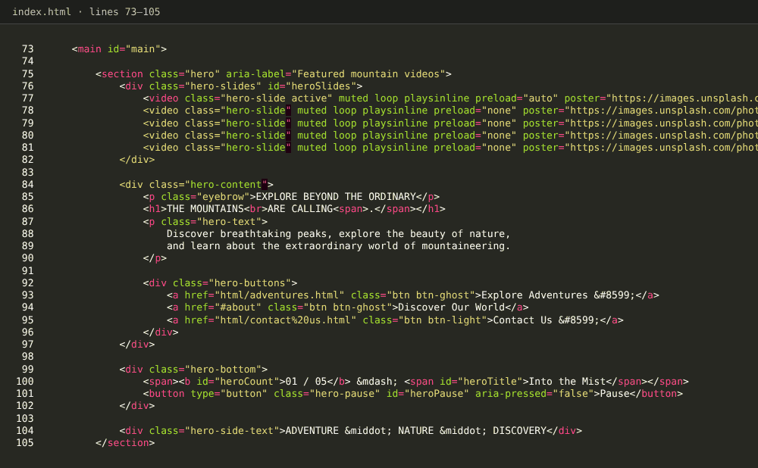
Figure 1: Home page source code: hero section

6.4 Ticker and Footer
- A bottom ticker (.ticker) with a LIVE label, a scrolling track (.ticker-track) that shows the site name, date, time, visitor location and welcome message, and a Share location button (#tickerLocate) that changes to “Update location” once a location is known
- A footer with five columns: about text and logo; link columns for Mountaineering, Safety and Community; and a Get In Touch column with address, e-mail, phone, opening hours and Instagram and Facebook links
- A copyright line whose year is filled in by JavaScript (#year) and a Back to top link

6.5 Accessibility Features
- Landmarks (header, nav, main, footer) and descriptive aria-label values
- Alternative text on images; decorative media marked aria-hidden
- Skip link, keyboard-accessible menu buttons, Escape closes menus and pop-ups, focus returns to the element that opened a pop-up
- aria-pressed on filter and pause buttons, role="dialog" on the welcome form and pop-ups
- Respect for prefers-reduced-motion (the hero slider starts paused and count-up numbers are skipped)

7. CSS Implementation
Styling is split into a global stylesheet (style.css) and page-specific stylesheets so the theme stays consistent while each page can add its own layout.

7.1 Global Styles (style.css)
- A light professional theme built on custom properties declared in :root: --ink #1a1f24, --teal #2f7f8c, --teal-dark #1f5f6b, --teal-light #9fd2da, --paper, --mist, --ok, --warn, --danger, plus font stacks, radius, shadow and header and ticker heights
- Typography using DM Sans for body text, Playfair Display for headings and Instrument Serif for the logo
- Layout of the sticky header, logo, navigation, dropdown panels and visitor box
- Reusable components: buttons (btn-primary, btn-ghost, btn-light, btn-outline, btn-small), cards, section bands (section, section-alt), eyebrow labels, forms, filter buttons, toast, welcome overlay and the footer
- The bottom ticker and its scrolling animation, the scroll progress bar and the reveal animation classes

7.2 Page Stylesheets
home.css styles the full-screen hero with stacked videos, the intro grid and the records and contact bands. The other stylesheets are short and add only what a page needs, for example the timeline in history.css, the peaks table in records.css, the photo wall, video wall and lightbox in gallery.css (139 lines), and the map and club list in clubs.css.

7.3 Responsive Design
- Flexbox and CSS Grid for fluid layouts
- Media queries in style.css at 1120 px (navigation collapses into a mobile menu), 900 px, 700 px, 600 px and 520 px (cards stack and spacing is reduced)
- Relative units and flexible images

8. JavaScript Implementation
All scripts are written in vanilla JavaScript (ES6) and use "use strict" inside an immediately invoked function, so nothing leaks into the global scope except window.AA.

8.1 Shared Script (main.js)
Feature | How It Works
Welcome form | On the first visit in a session buildWelcome() creates a modal dialog asking for full name, location, e-mail and contact number. Rules: name and location at least 2 characters, e-mail pattern, phone pattern of 7 to 18 digits. A valid form saves aa_visitor, sets aa_entered, counts the visit and shows a welcome pop-up that closes after 5 seconds
Use my location | locate() calls navigator.geolocation.getCurrentPosition, then asks OpenStreetMap Nominatim (fetch) for a City, Country name; if that fails the coordinates are used
Live ticker | updateTicker() rebuilds the ticker text every second with the date, time, location and visitor name
Share location | Button #tickerLocate calls locate(), saves the result and shows a toast. If permission is already granted it runs automatically
Visitor counter | countVisit() increments aa_visits once per session and animates the number in #visitorCount
Navigation dropdowns | Click toggles an open class and aria-expanded; hover-out closes menus on wide screens; clicking elsewhere or pressing Escape closes them; the header gets a scrolled class after 30 px
Mobile menu | #menuToggle shows and hides the navigation below 1120 px and locks page scrolling while open
Footer year | Writes the current year into #year
Animations | initAnimations() staggers card grids, slides image blocks in from their side, draws the scroll progress bar and counts up numbers such as “8,849 m”; initReveal() uses an IntersectionObserver to add the visible class to .reveal elements
Shared helpers | window.AA exposes $, $$, store, locate, toast and visitor() to page scripts

8.2 Home Script (home.js)
- Hero video slider: the first video loads at start; the others use a data-src attribute and are loaded just before they are needed, which saves bandwidth.
- A slide changes every 9 seconds. The counter (for example “01 / 05”) and the slide title are updated and the outgoing video is paused after the fade.
- The Pause / Play button stops and resumes the slider and updates aria-pressed.
- The slider also pauses when the browser tab is hidden and starts paused when the user prefers reduced motion.

8.3 Page Scripts
Script | Page | What it does
about us.js | About Us | Counts up the numbers marked data-count when they scroll into view
history.js | History | Era filter buttons show or hide timeline items (16 items) and restart their animation
adventures.js | Types and Styles | Filter buttons for the six adventure cards; clicking a row of the difficulty table highlights it
techniques.js | Techniques | Category filter (rock, snow, glacier, altitude, navigation) for 12 technique cards
records.js | Records | Search box, range filter (including Pakistan) and sortable columns for the table of 14 peaks, with a “x of 14 peaks shown” count
safety.js | Safety Guidelines | Ten-item pre-climb checklist with a progress bar; ticked items are saved in aa_checklist; Reset button
hazards.js | Hazards | Search over 11 hazard cards and a pop-up with the full description stored in a JavaScript object; image fallback on error
sheltering.js | Sheltering | Booking pop-up for 12 shelters: estimated total = price × nights (1 to 30), validated form saved in aa_bookings
gallery.js | Gallery | Hero video rotation (8 s), category filter for 68 photos, hover preview of 12 video cards and a lightbox with previous, next and Escape keys
clubs.js | Clubs and Camps | Array of 16 organisations, Leaflet map with markers, region filter, distance sort with the haversine formula, “Find Clubs Near Me”
news.js | Latest News | Topic filter for 10 news cards
feedback.js | Feedback | Validated form with star rating and character counter, saved in alpineAscentsFeedback
contact us.js | Contact Us | Pre-fills saved visitor data, validates the form and saves entries in aa_messages

8.4 Browser APIs and Libraries
- DOM API, Events API and Timers (setTimeout, setInterval, requestAnimationFrame)
- Geolocation API and Permissions API (navigator.permissions.query)
- Fetch API (Nominatim and the world map data)
- IntersectionObserver (reveal and count-up effects)
- localStorage and sessionStorage
- Leaflet 1.9.4 and TopoJSON client 3.1.0 (Clubs page only), with country shapes from world-atlas@2.0.2

9. Website Pages Implementation with Source Code Screenshots
Each page below is shown with a screenshot of the running page and screenshots of its main source code. The pages share the same header, ticker and footer, so only the page-specific content is described.
# | Page | File | Description
1 | Home | index.html | Hero video slider, introduction, essentials, records, gallery, news and call to action
2 | About Us | html/about us.html | Who we are, mission, core values and journey, with count-up numbers
3 | History | html/history.html | Timeline from Mont Blanc to the 8,000 m peaks with an era filter
4 | Types and Styles | html/adventures.html | Six types of mountaineering, climbing styles and difficulty table
5 | Techniques | html/techniques.html | Twelve rope, snow, ice and altitude skills with a category filter
6 | Records | html/records.html | Highest peaks table with search, filter and sorting; Seven Summits
7 | Safety Guidelines | html/safety.html | Safety foundation, rules and a saved pre-climb checklist
8 | Hazards | html/hazards.html | Eleven hazards with search and detail pop-ups; emergency steps
9 | Sheltering | html/sheltering.html | Shelter types, camping habits and a shelter booking form
10 | Gallery | html/gallery.html | 68 photos with filters and lightbox; 12 videos
11 | Clubs and Camps | html/clubs.html | World map of 16 organisations (Geolocation) and success stories
12 | Latest News | html/news.html | Ten recent developments with a topic filter
13 | Feedback | html/feedback.html | Feedback form with star rating
14 | Contact Us | html/contact us.html | Contact form, details, location and FAQ
Note on screenshots: the screenshots were taken at 1366 × 768 from the project files. Photographs that the site loads from Unsplash and the hero videos may look different on a computer with an internet connection and the videos folder.

9.1 Home Page
Files: index.html, css/home.css, js/home.js (plus the shared files). The home page opens with the welcome form (first visit in a session). After the visitor submits valid details, a welcome pop-up appears and the hero video slider, introduction and the other sections are shown.
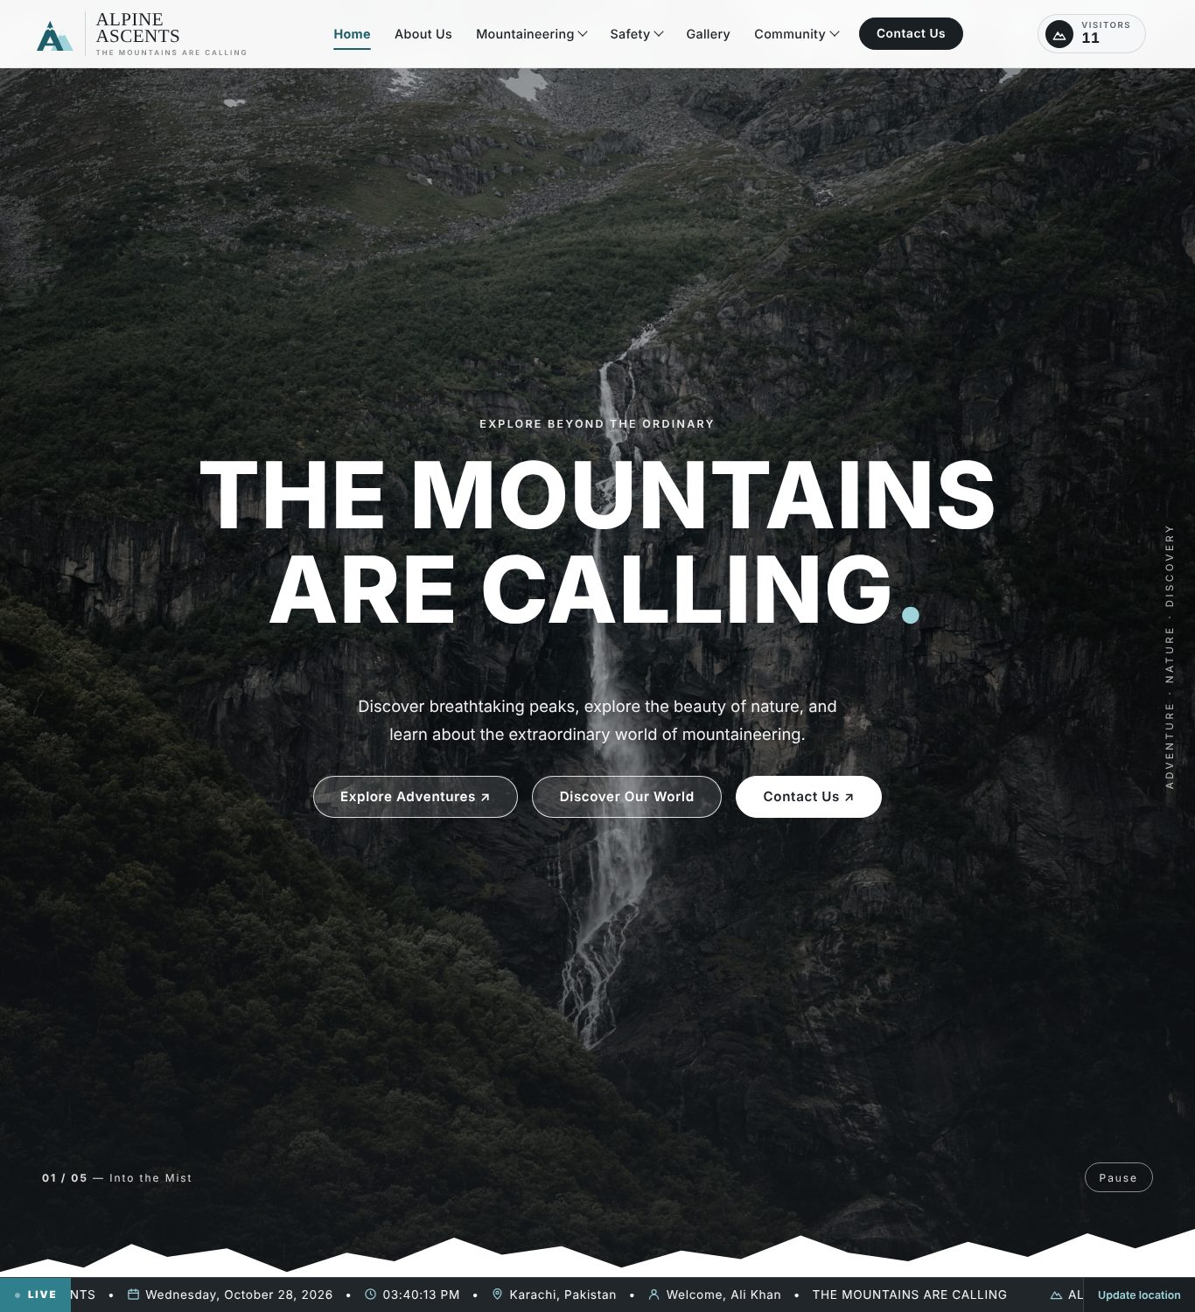
Figure 2: Home page: hero banner, navigation, visitor count and live ticker
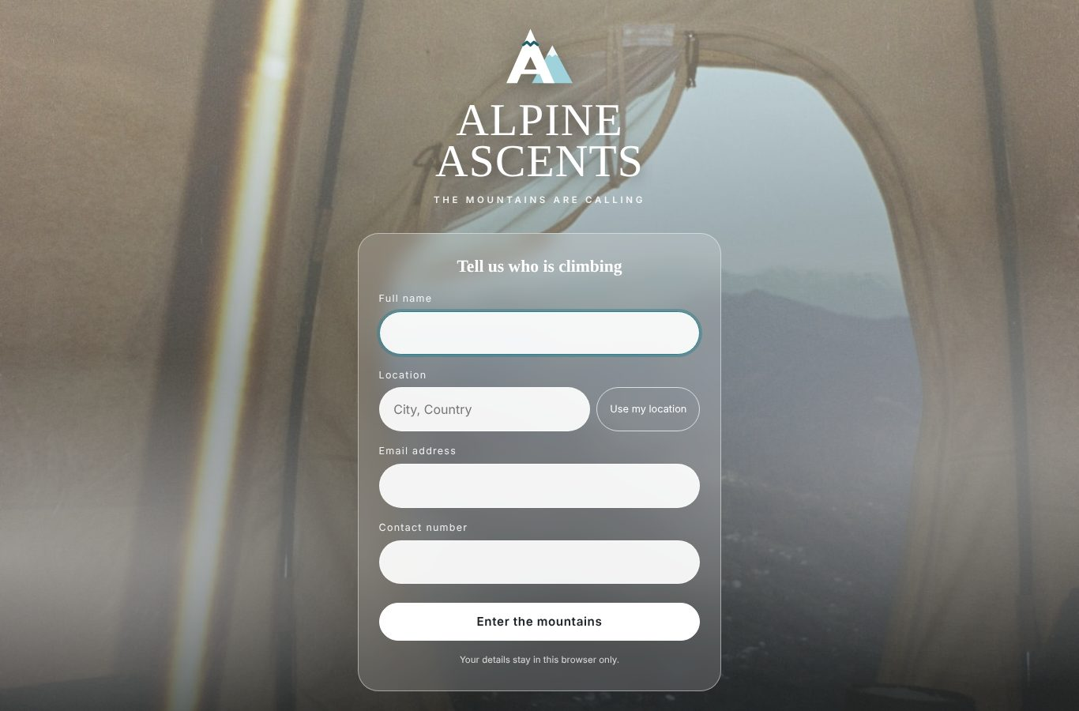
Figure 3: Welcome form shown on the first visit
Figure 4: Source code: hero section (index.html)

9.2 About Us
Files: html/about us.html, css/about us.css, js/about us.js. The page explains who Alpine Ascents is, the mission, the core values and the journey from first step to summit. Numbers marked with data-count are animated when they scroll into view.
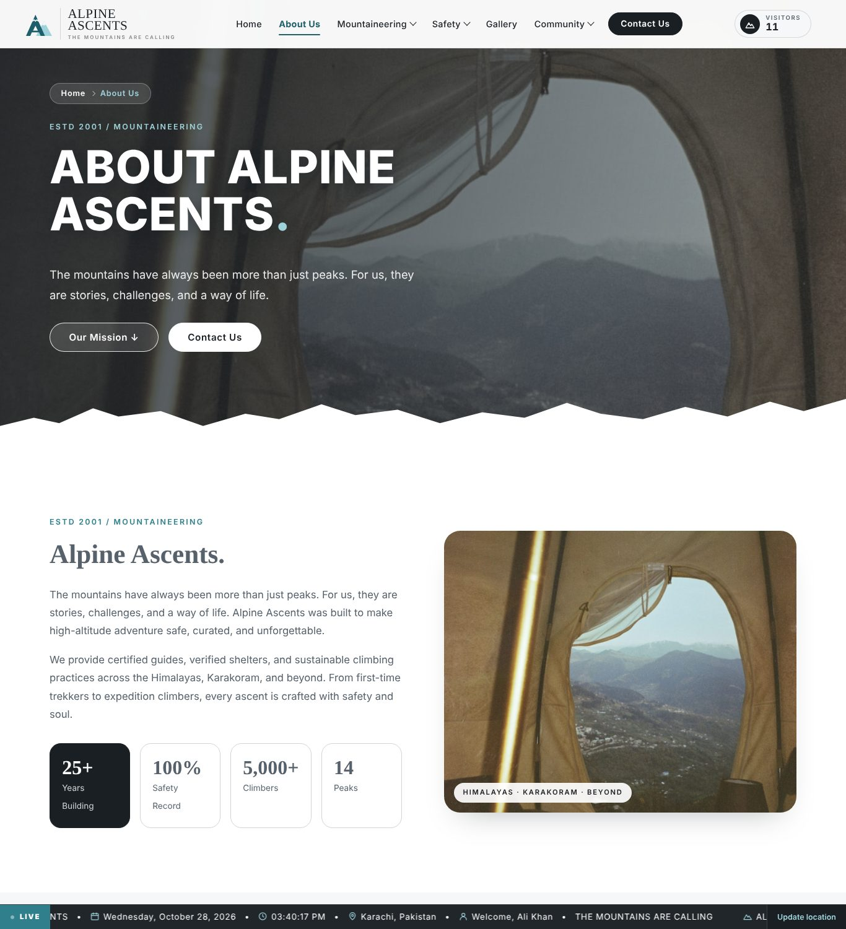
Figure 5: About Us page
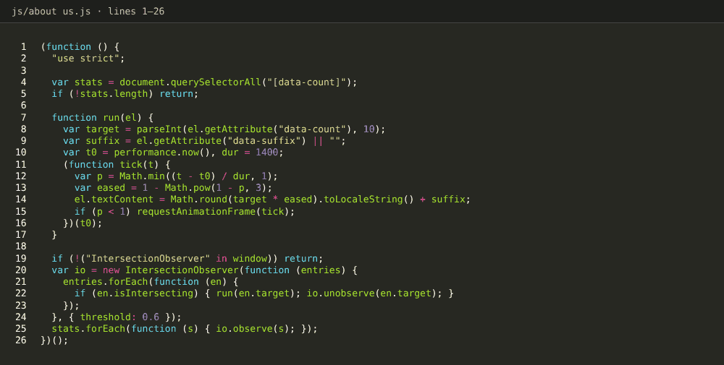
Figure 6: Source code: about us.js (count-up numbers)

9.3 History
Files: html/history.html, css/history.css, js/history.js. A timeline of 16 events from Mont Blanc (1786) to the 8,000-metre peaks, four chapters of climbing, how gear changed climbing and Pakistan’s giants. The era buttons filter the timeline.
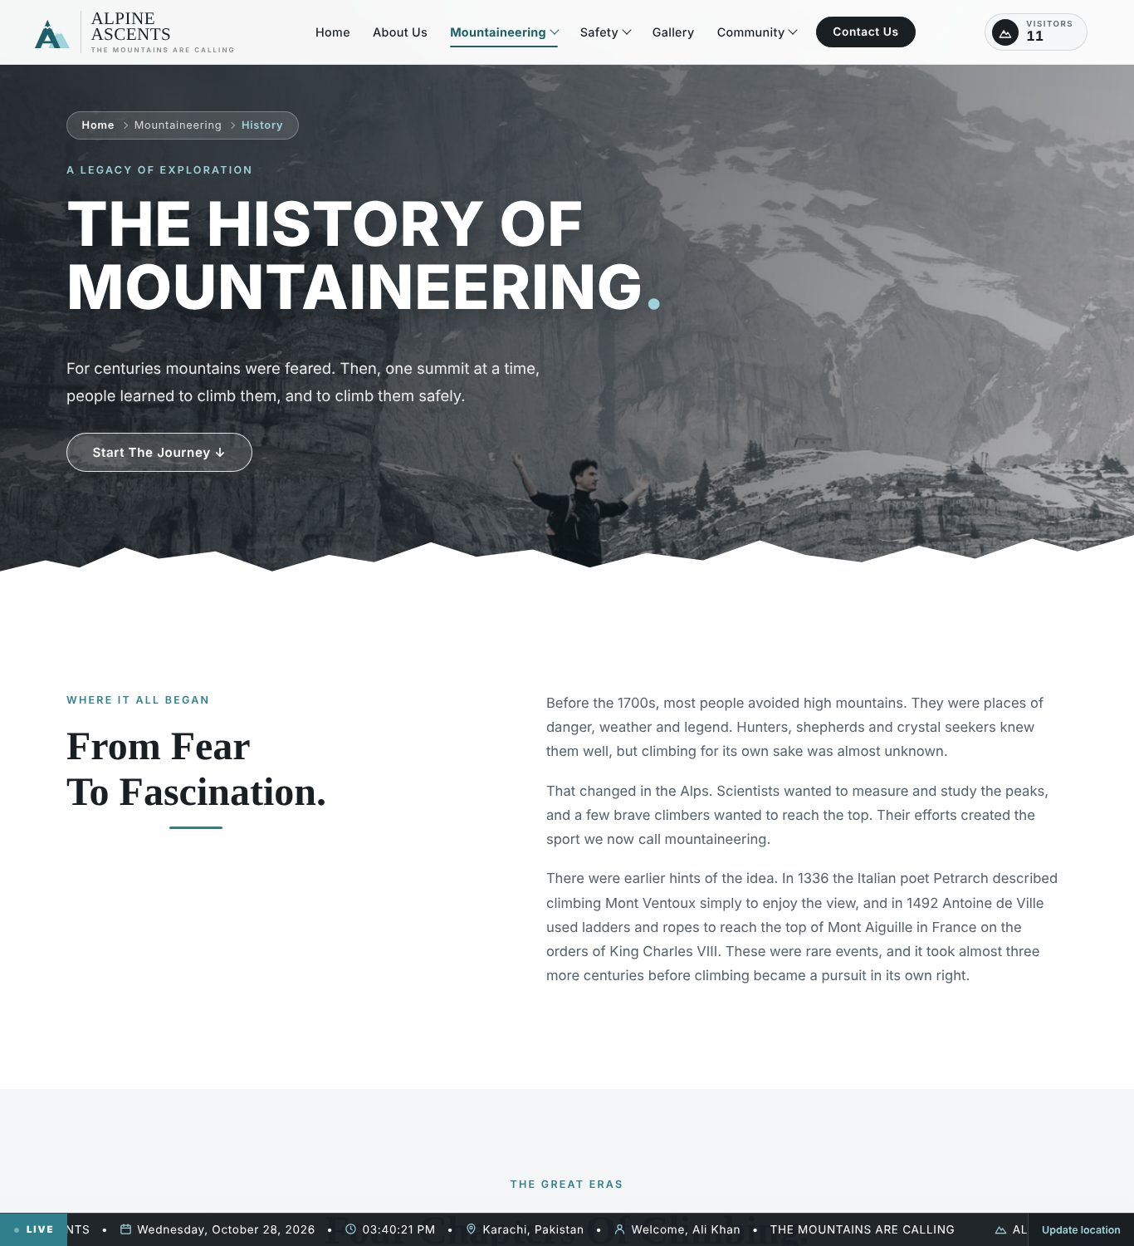
Figure 7: History page
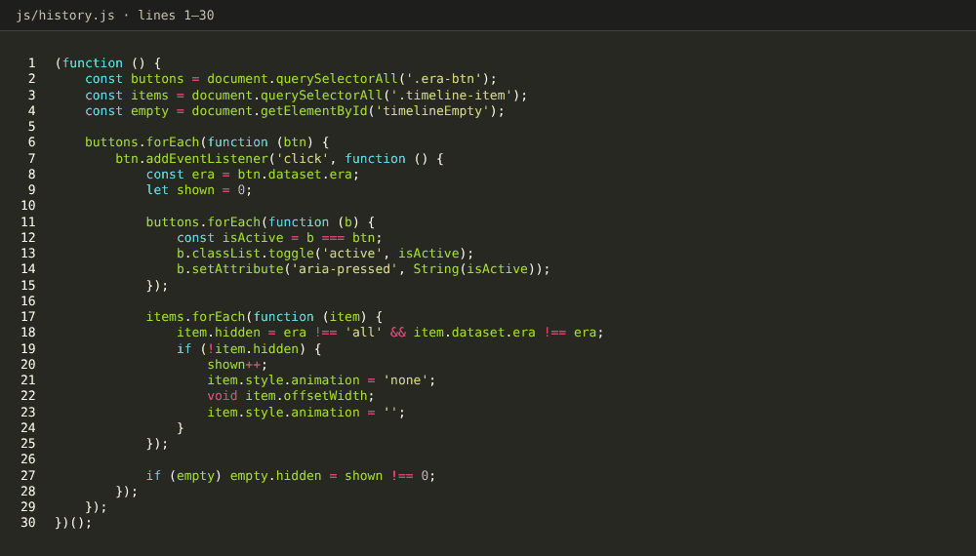
Figure 8: Source code: history.js (era filter)

9.4 Types and Styles
Files: html/adventures.html, css/adventures.css, js/adventures.js. Six adventure cards with filter buttons, how big mountains are climbed, a difficulty table (rows can be selected), four steps before leaving, a packing list and seasons.
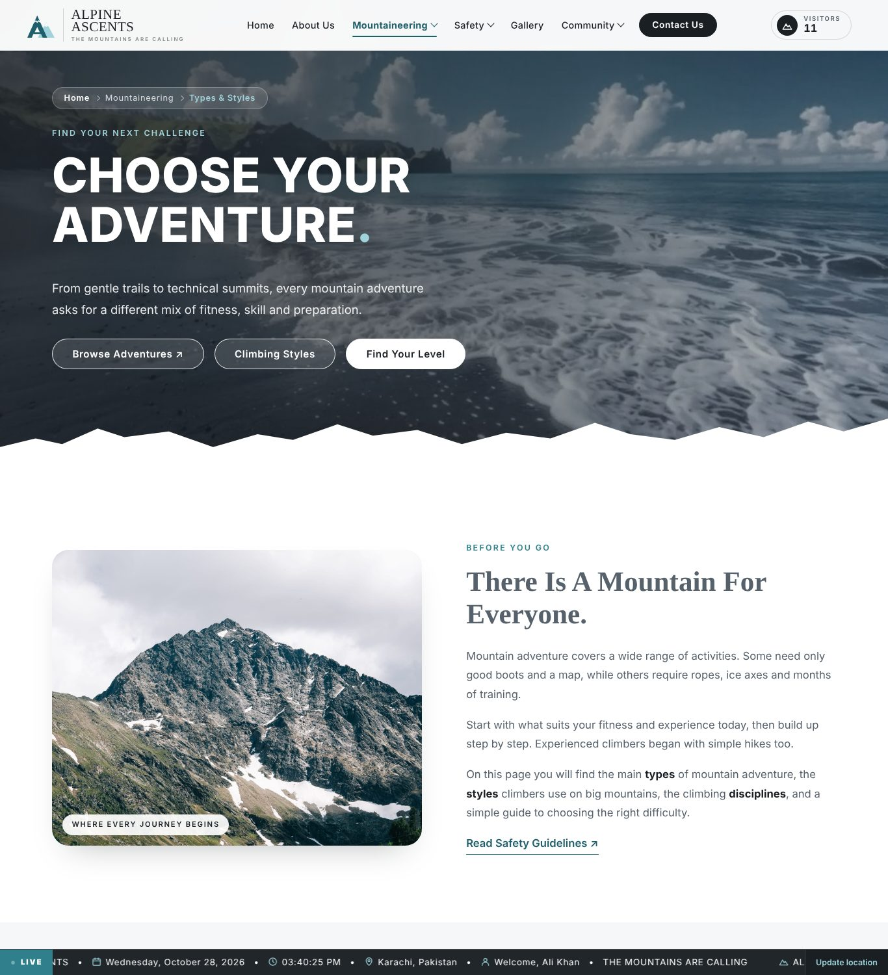
Figure 9: Types and Styles page
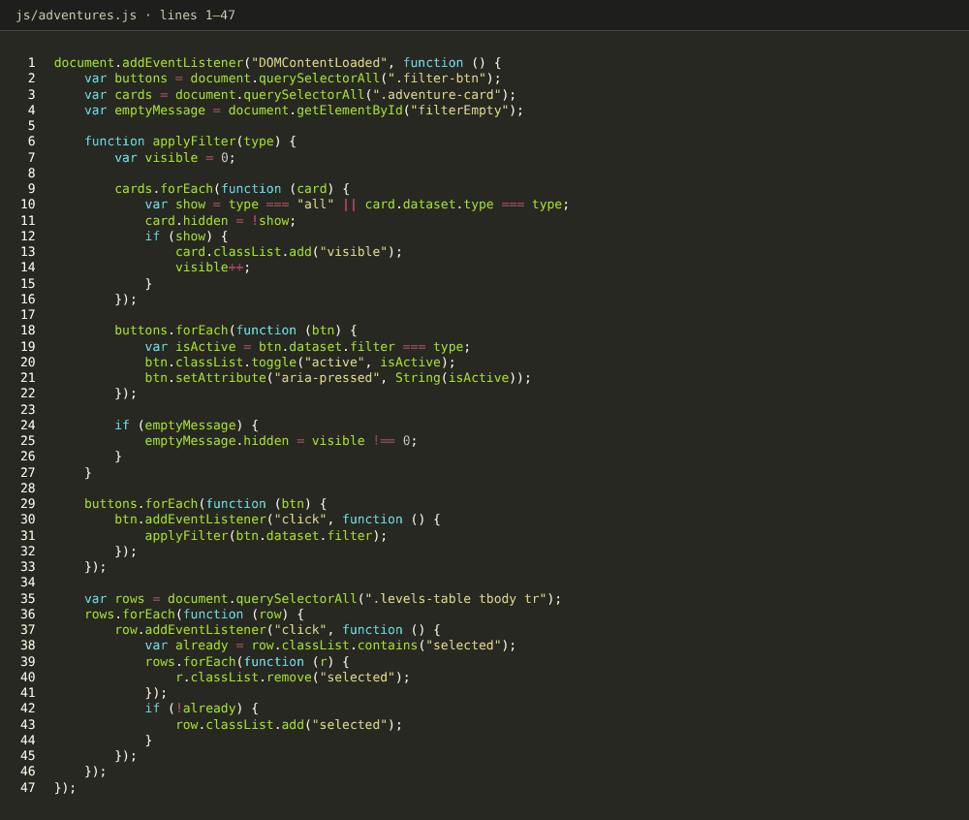
Figure 10: Source code: adventures.js (filter and table rows)

9.5 Techniques
Files: html/techniques.html, css/techniques.css, js/techniques.js. Twelve technique cards (rock, snow, glacier, altitude and navigation skills) with a category filter, the calls climbers use, a safe learning path and club advice.
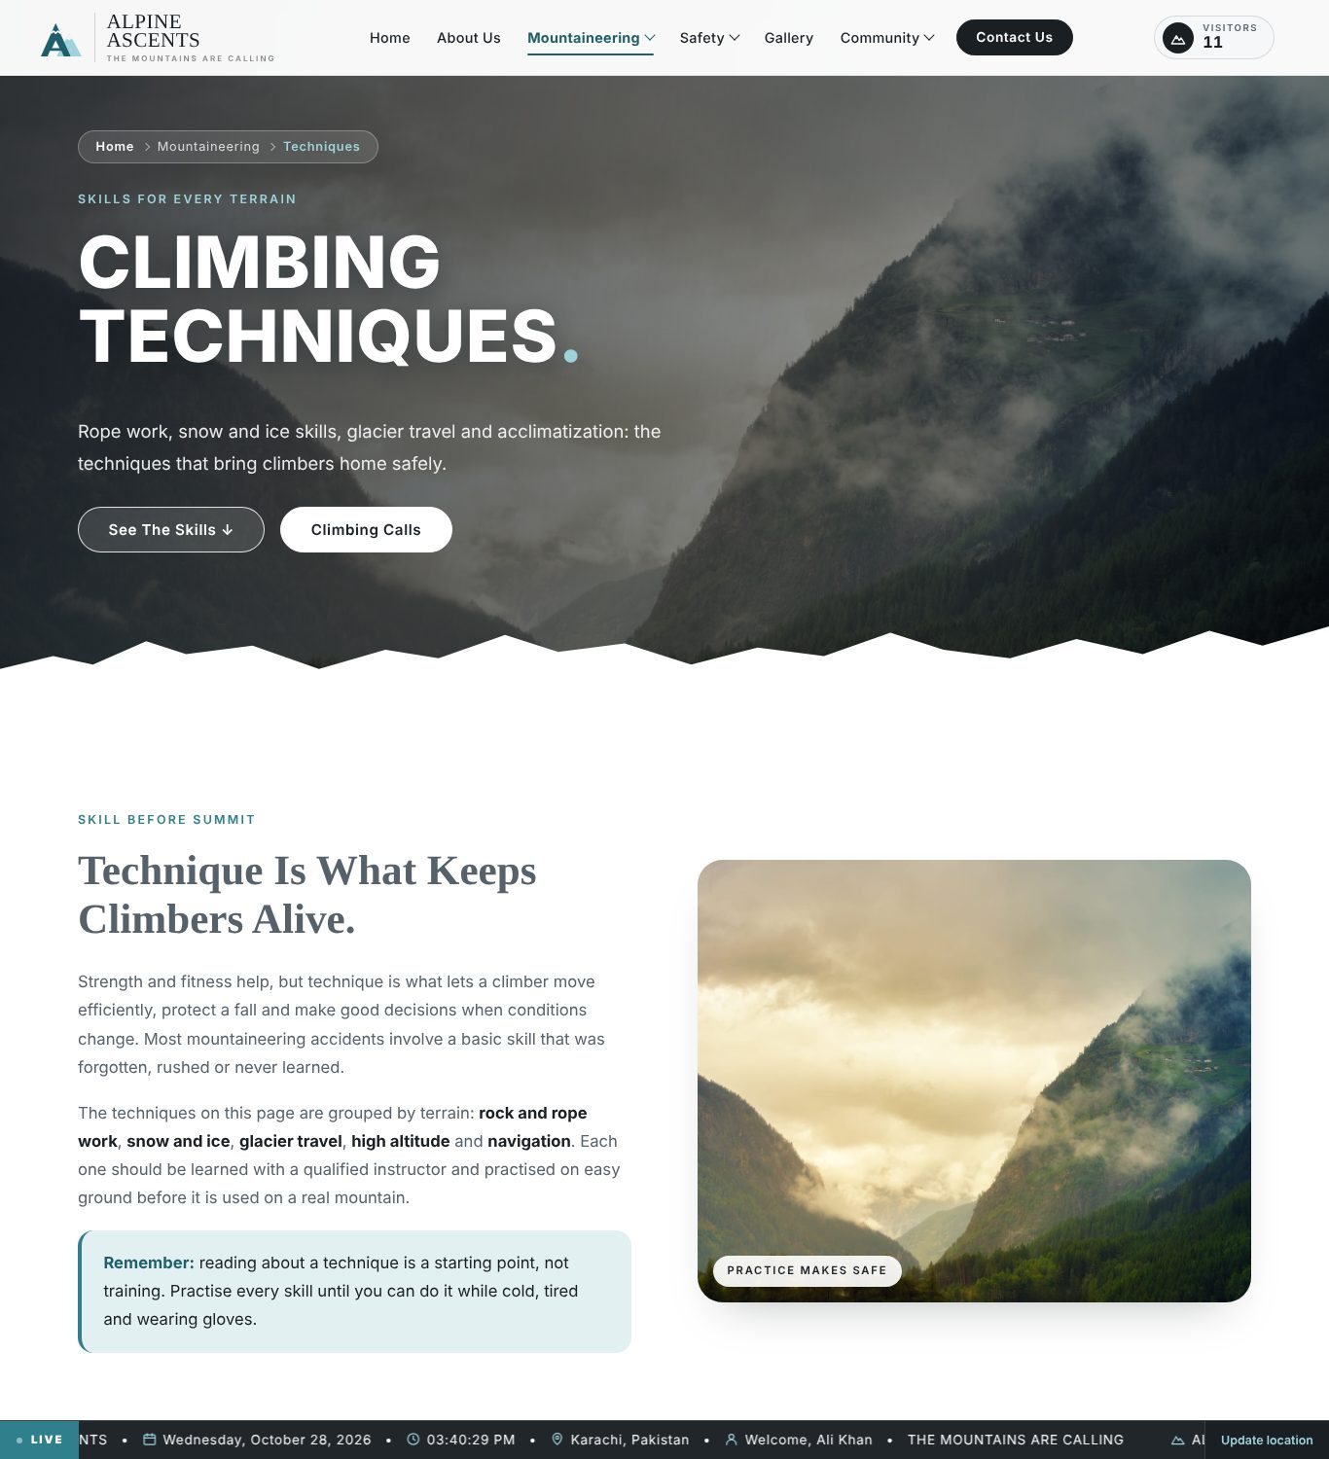
Figure 11: Techniques page
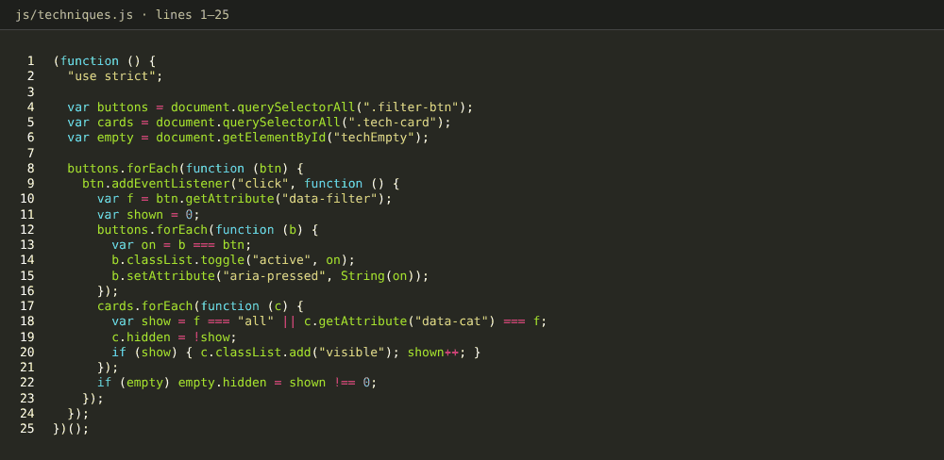
Figure 12: Source code: techniques.js (category filter)

9.6 Records
Files: html/records.html, css/records.css, js/records.js. Key numbers, a table of the 14 peaks above 8,000 m that can be searched, filtered by range and sorted, the Seven Summits and record-setting climbers.
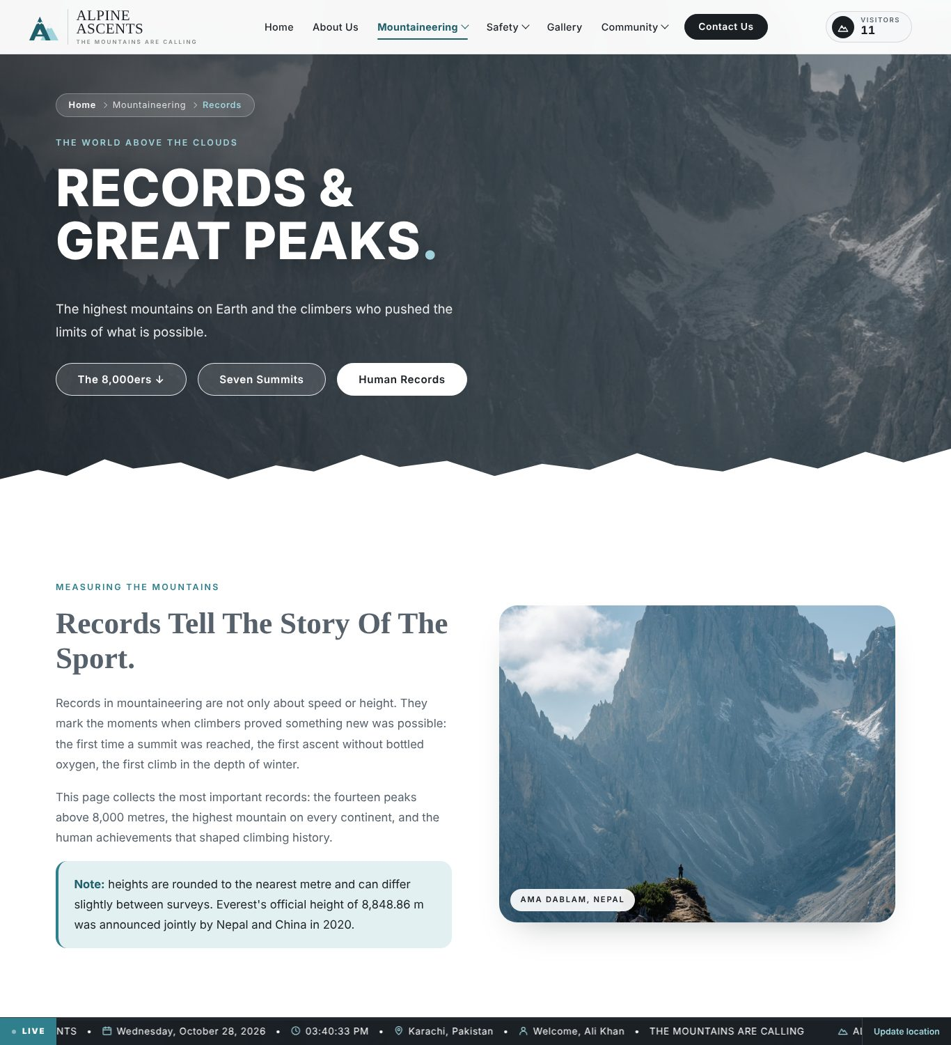
Figure 13: Records page
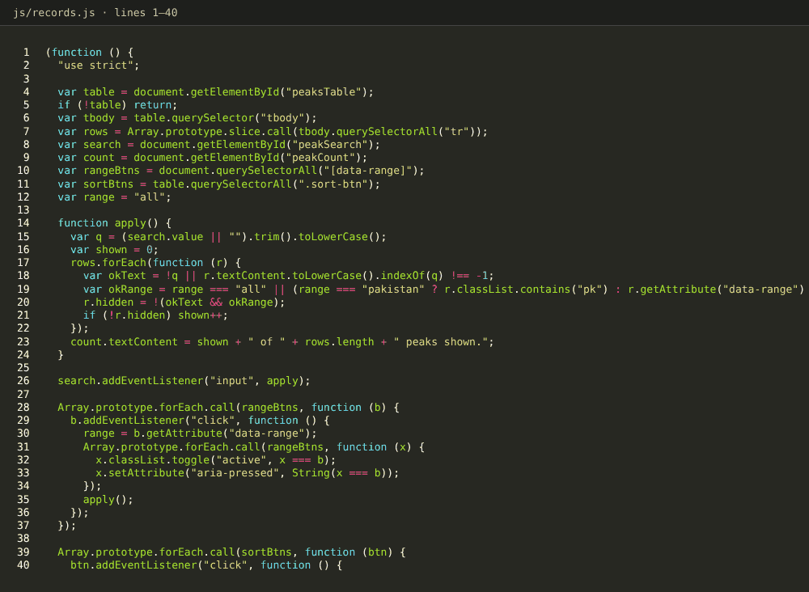
Figure 14: Source code: records.js (search, filter and sort)

9.7 Safety Guidelines
Files: html/safety.html, css/safety.css, js/safety.js. Safety foundation, altitude sickness, rules for every visitor, three rules that save lives and an interactive pre-climb checklist whose progress is saved in the browser.
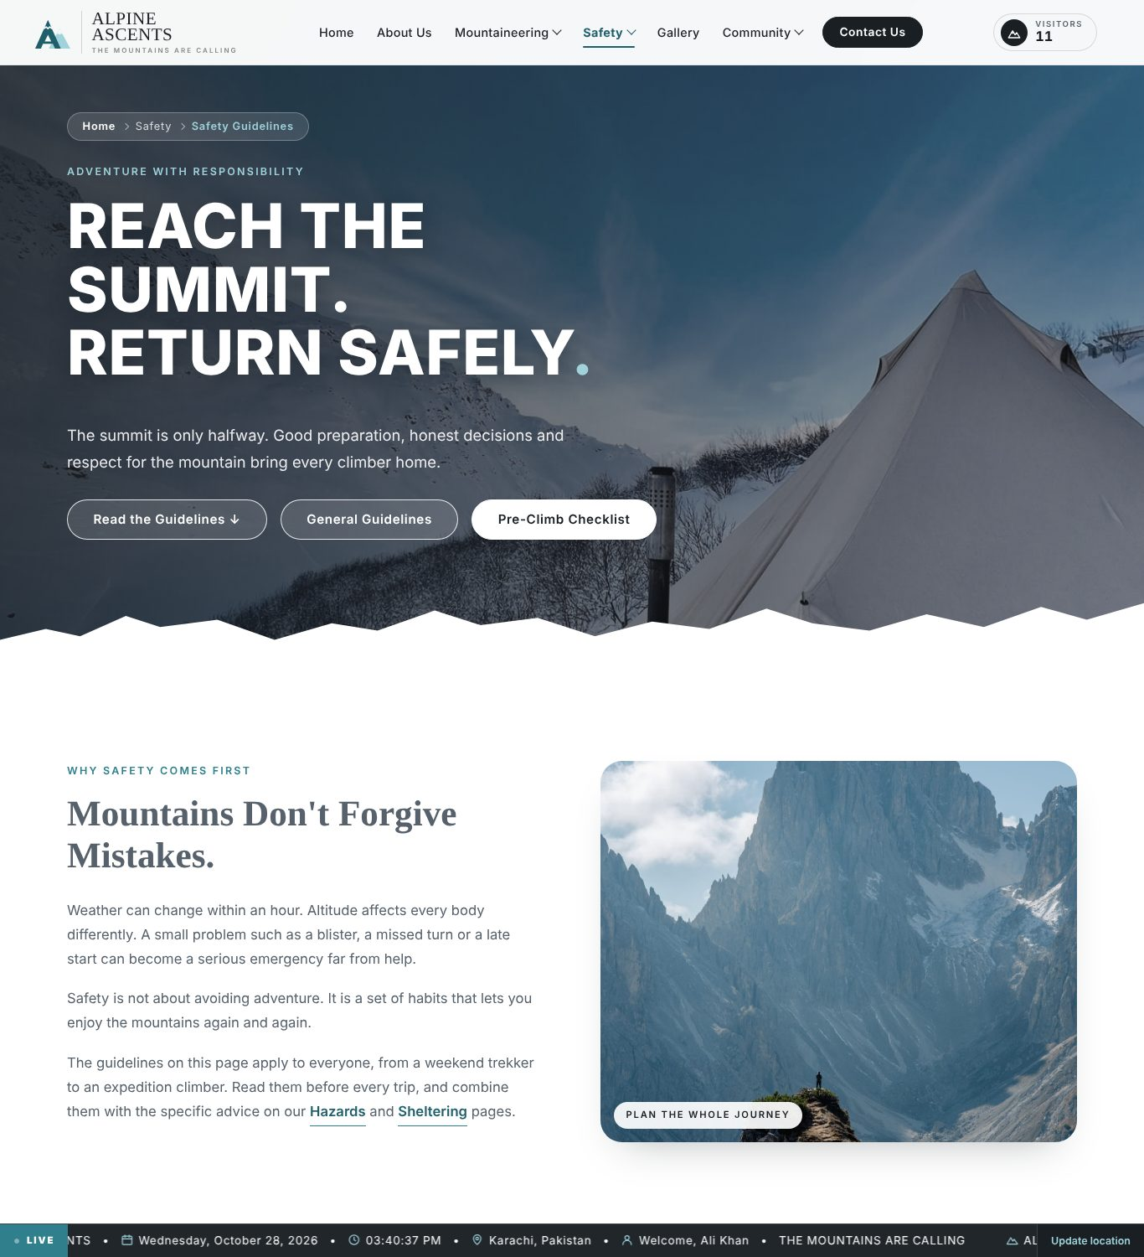
Figure 15: Safety Guidelines page
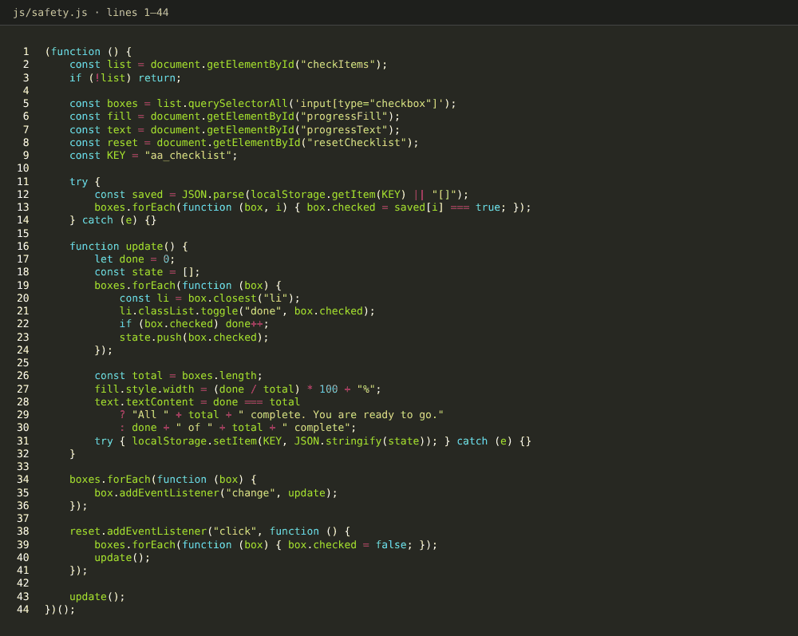
Figure 16: Source code: safety.js (checklist and progress bar)

9.8 Hazards
Files: html/hazards.html, css/hazards.css, js/hazards.js. Eleven hazard cards (avalanche, extreme weather, altitude sickness, crevasses, lightning, wildlife, dehydration, rockfall, frostbite, hypothermia and falls). The search box filters the cards and clicking a card opens a pop-up with the full description.
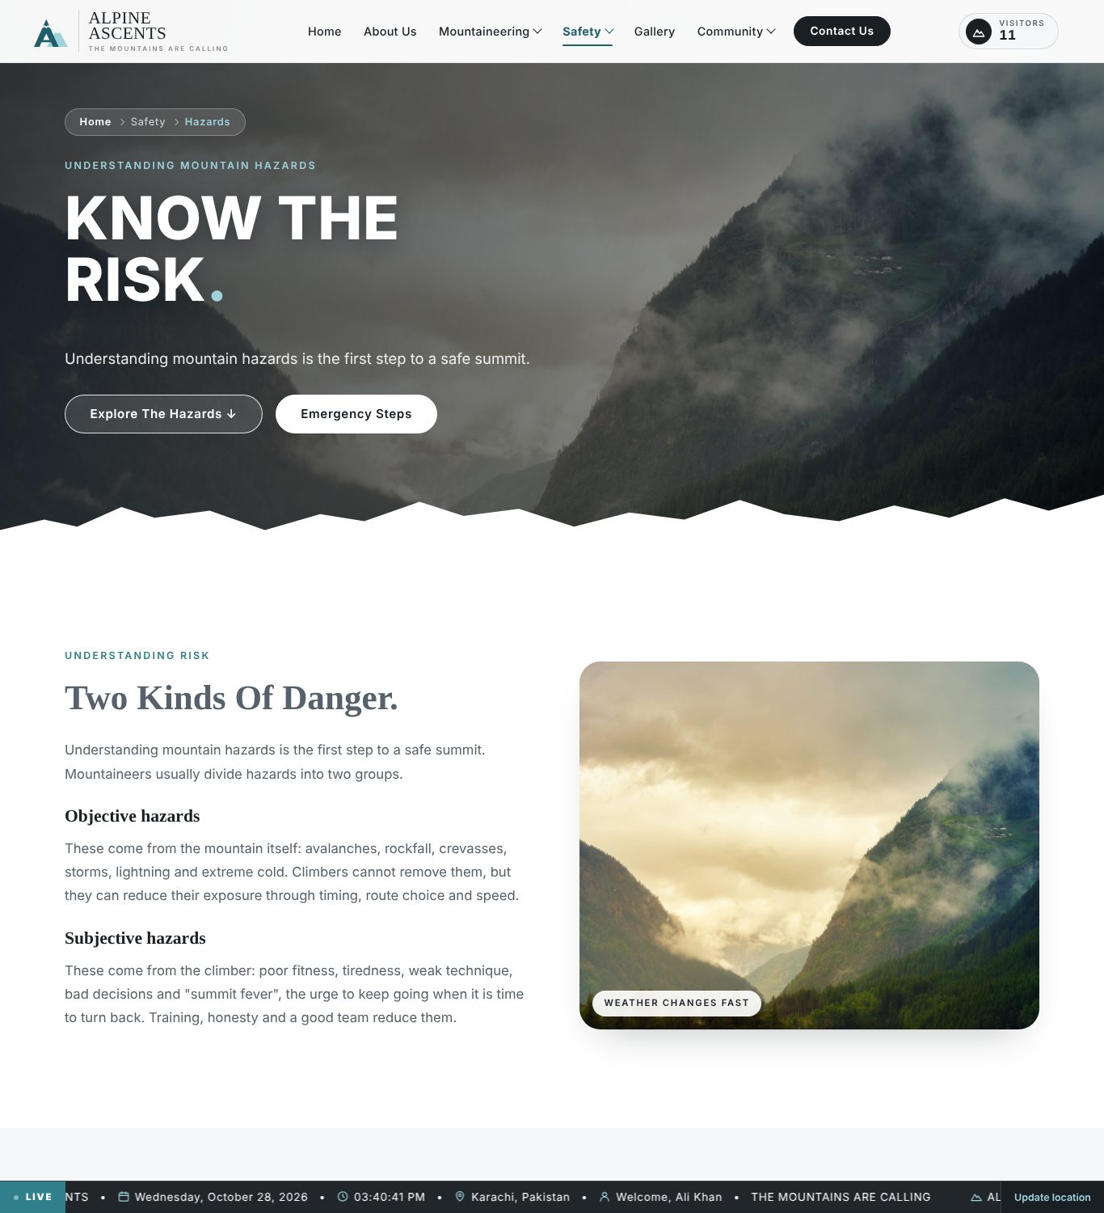
Figure 17: Hazards page
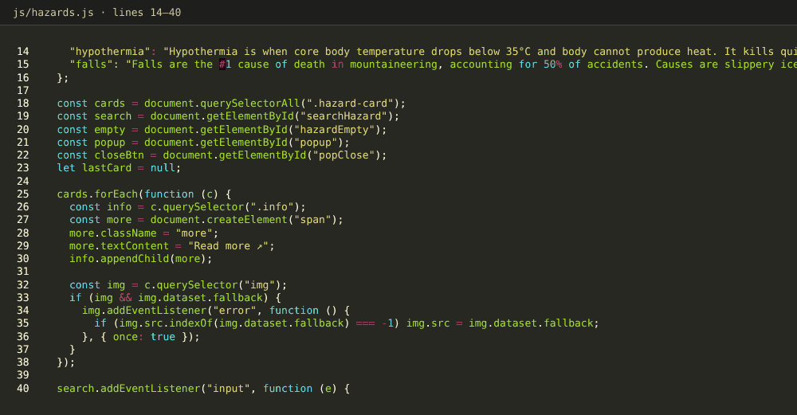
Figure 18: Source code: hazards.js (search and pop-up)

9.9 Sheltering
Files: html/sheltering.html, css/sheltering.css, js/sheltering.js. Four ways to spend the night, where to pitch, five habits for a warm night and twelve bookable shelters with a price per night. Clicking a shelter opens a booking form with name, nights, location, e-mail and phone and an estimated total. The booking is stored in the browser only; no payment is taken.
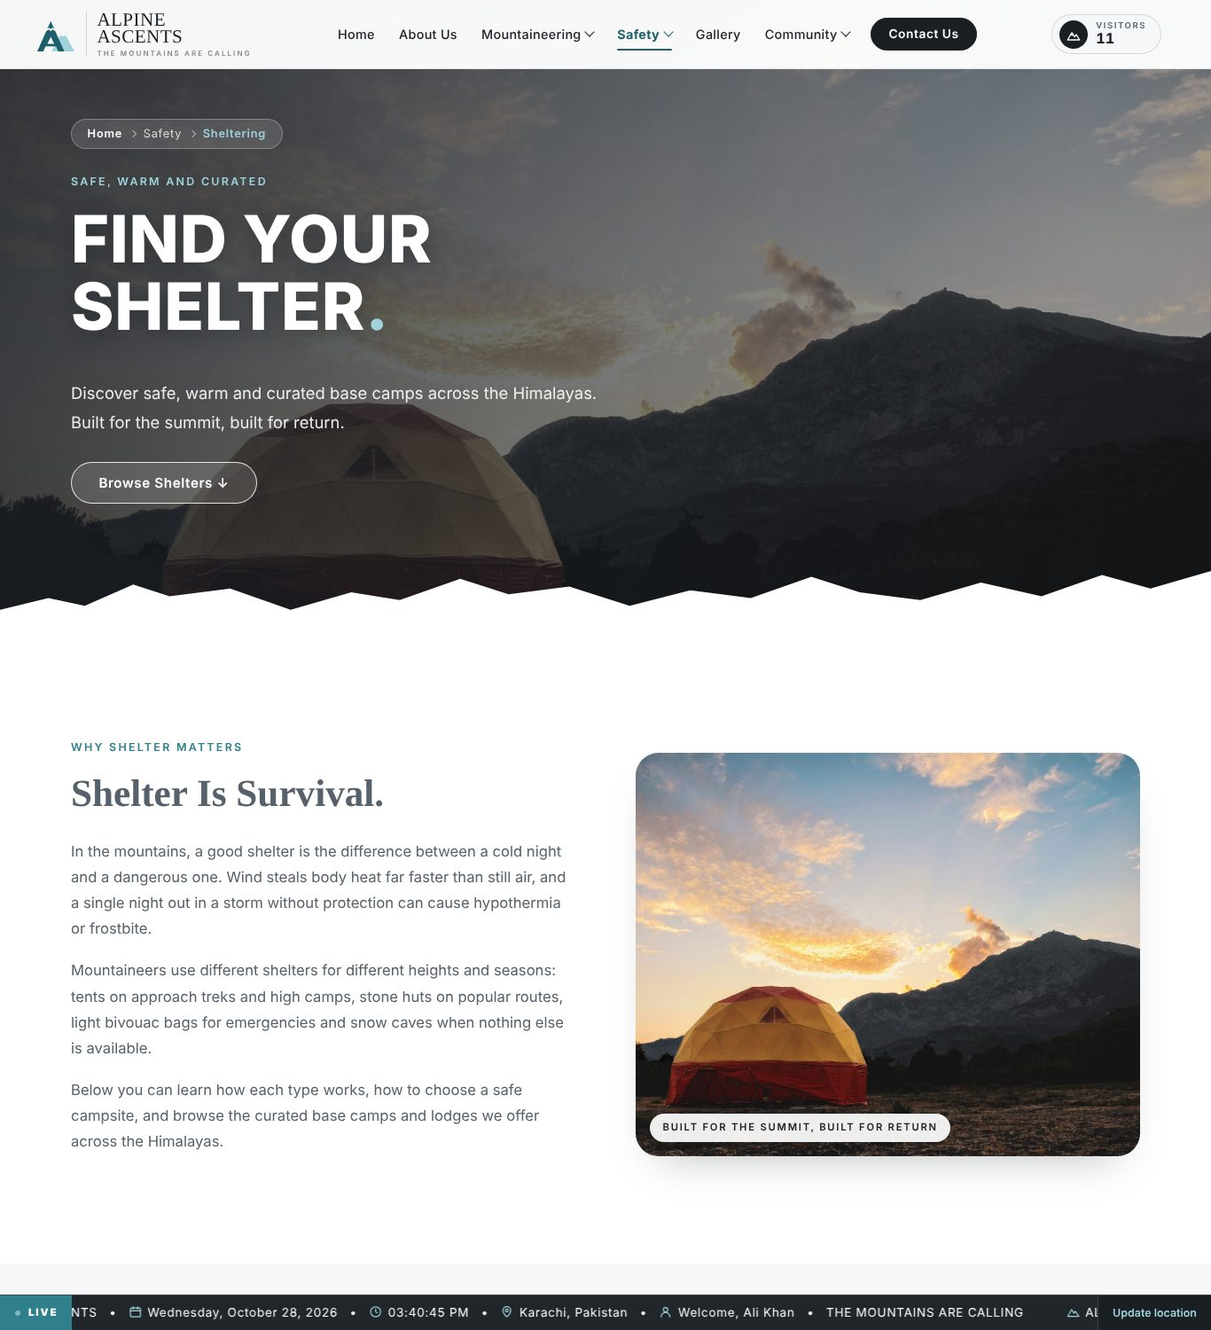
Figure 19: Sheltering page
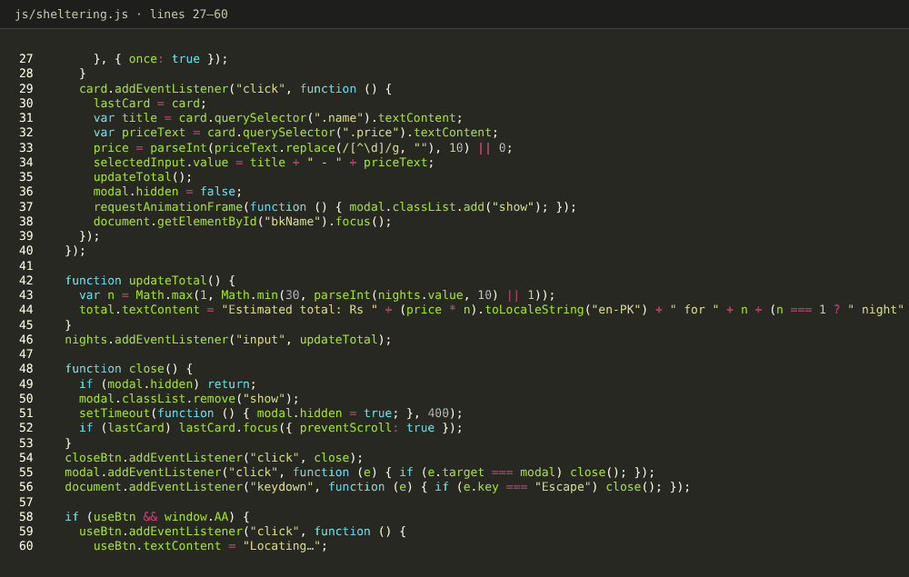
Figure 20: Source code: sheltering.js (booking and total)

9.10 Gallery
Files: html/gallery.html, css/gallery.css, js/gallery.js. A hero video rotation, 68 photographs with category filters and a lightbox (previous, next and Escape), and a wall of 12 videos that preview on hover and play in the lightbox.
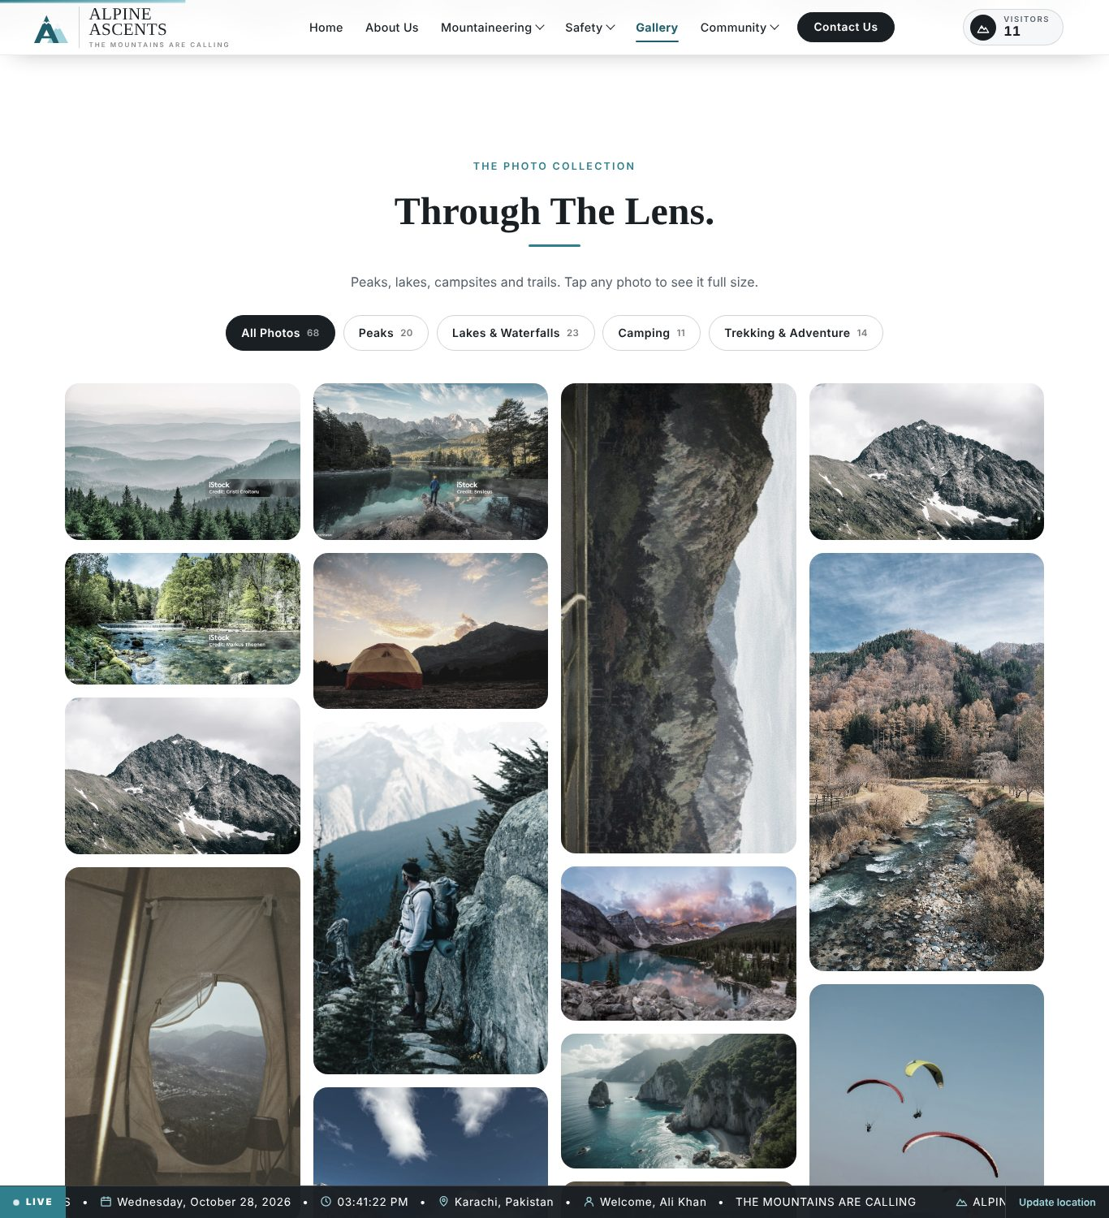
Figure 21: Gallery page
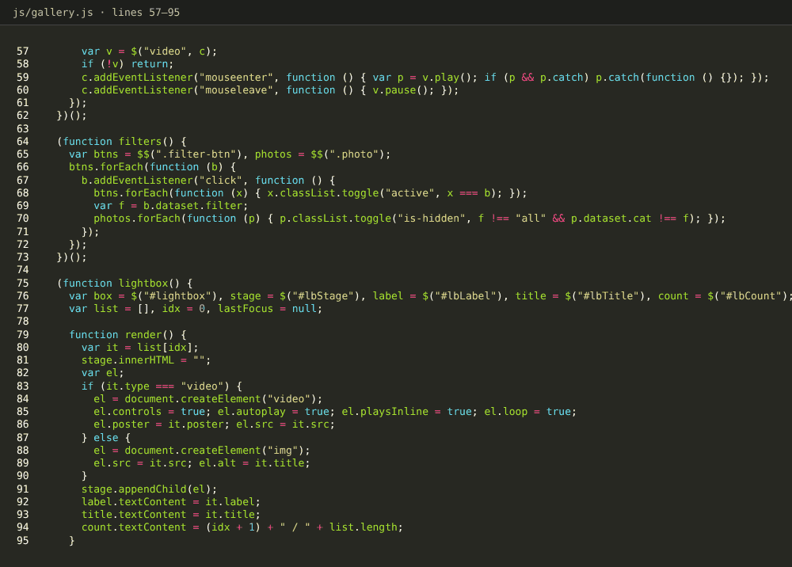
Figure 22: Source code: gallery.js (filters and lightbox)

9.11 Clubs and Camps
Files: html/clubs.html, css/clubs.css, js/clubs.js. An interactive Leaflet map with 16 mountaineering organisations, region filters and a list with Website and Google Maps links. “Find Clubs Near Me” uses the visitor’s location to sort the clubs by distance. The page also includes success stories from organised camps. The map and country shapes need an internet connection; without it the list is still shown.
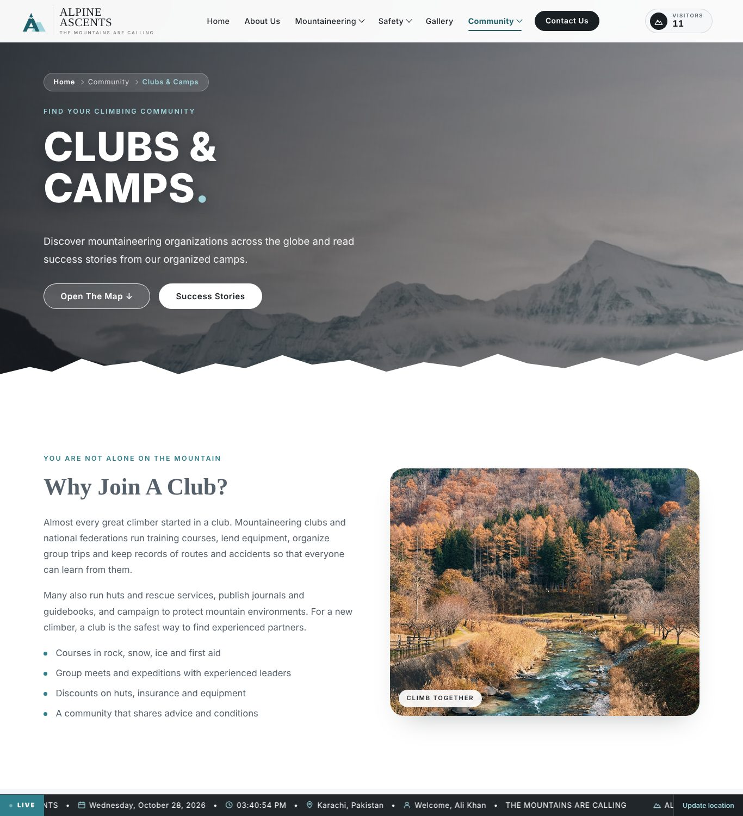
Figure 23: Clubs and Camps page
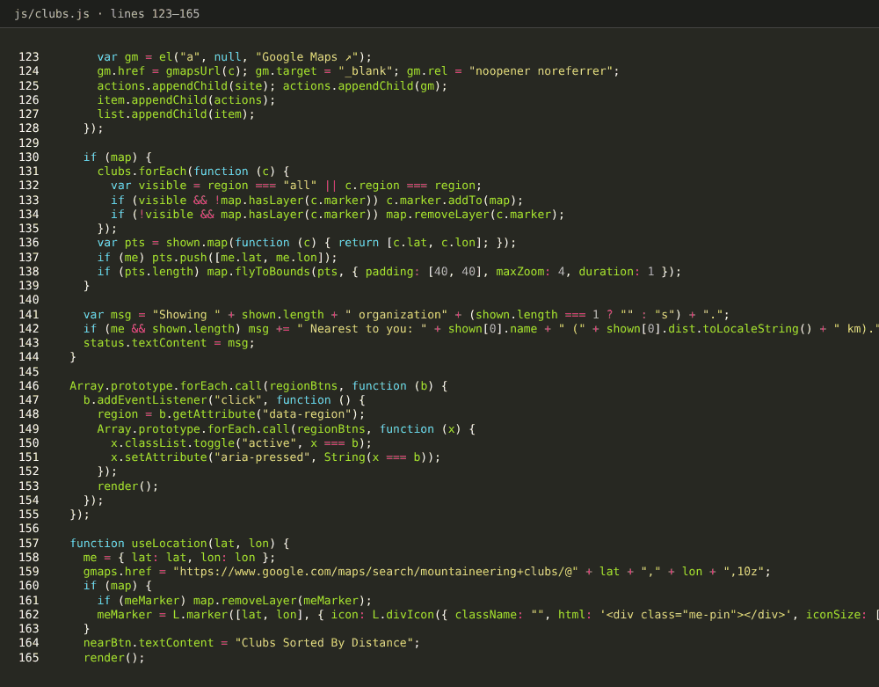
Figure 24: Source code: clubs.js (Leaflet map and markers)

9.12 Latest News
Files: html/news.html, css/news.css, js/news.js. Ten recent developments in mountaineering with a topic filter, a list of trusted sources and a prompt to tell the team what was missed.
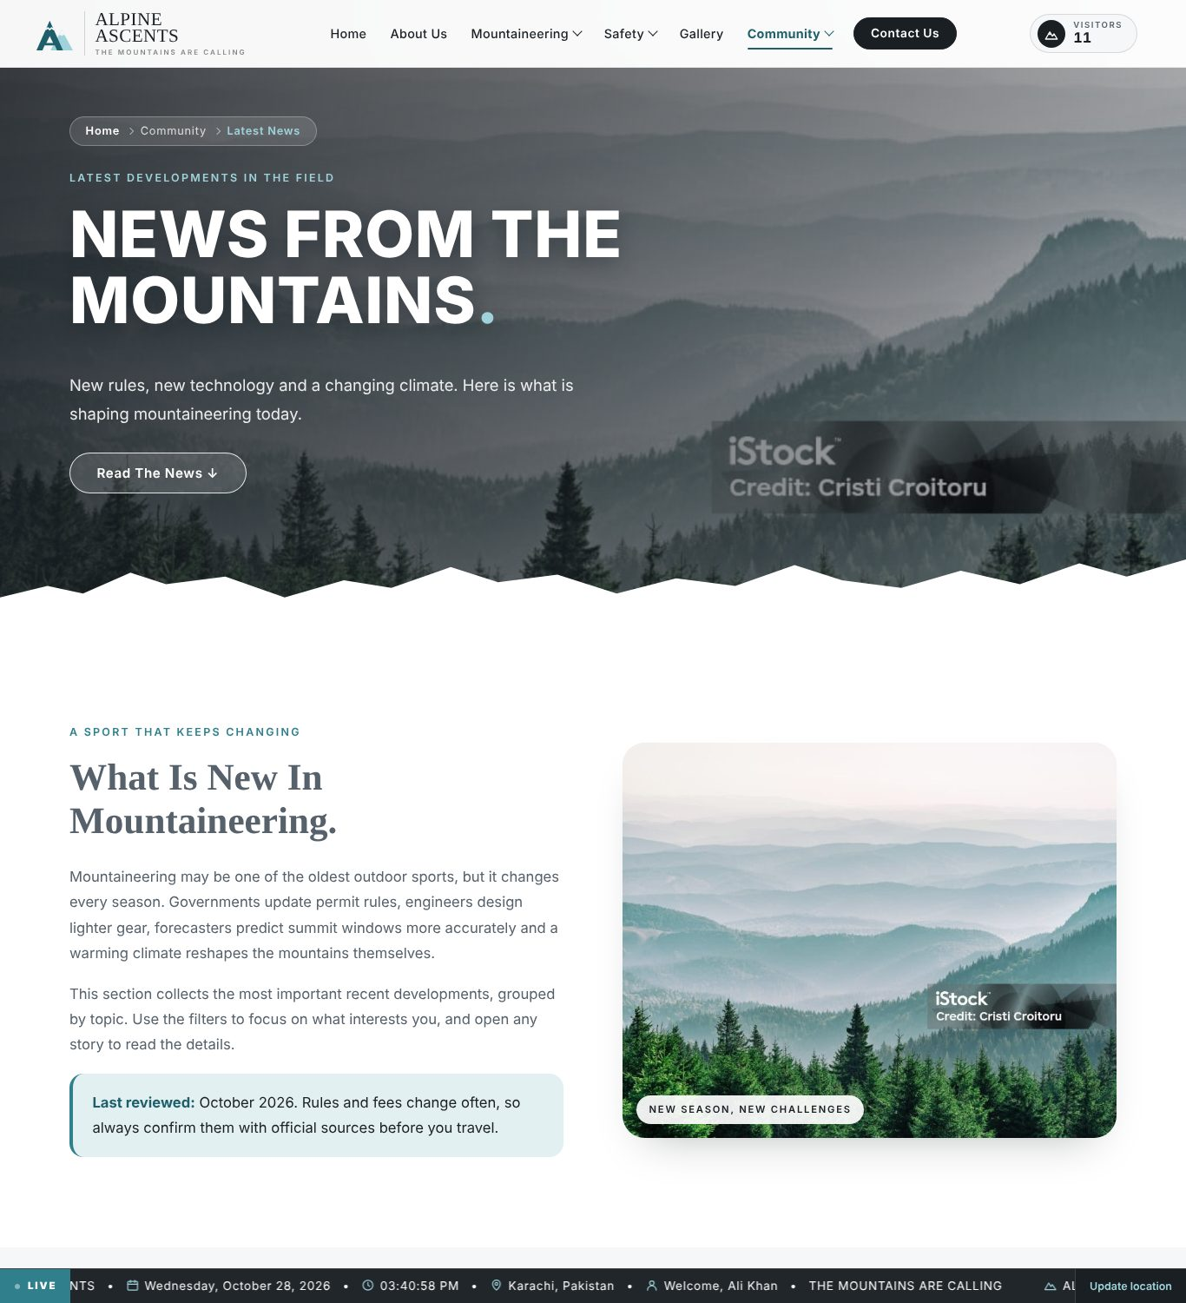
Figure 25: Latest News page
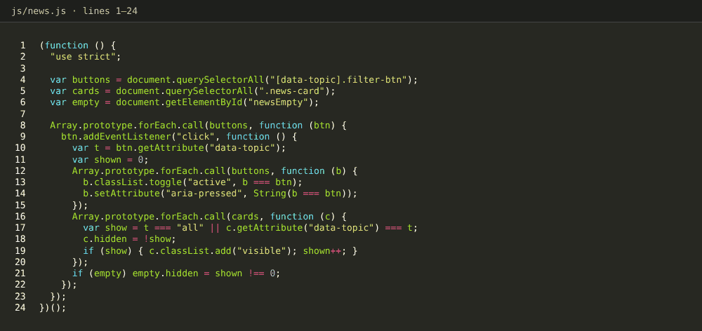
Figure 26: Source code: news.js (topic filter)

9.13 Feedback
Files: html/feedback.html, css/feedback.css, js/feedback.js. A form with name, optional e-mail, topic, star rating, message (at least 10 characters, with a live counter) and a “may we reply” option. Errors are shown under each field. A valid entry is saved in alpineAscentsFeedback and a thank-you panel replaces the form.
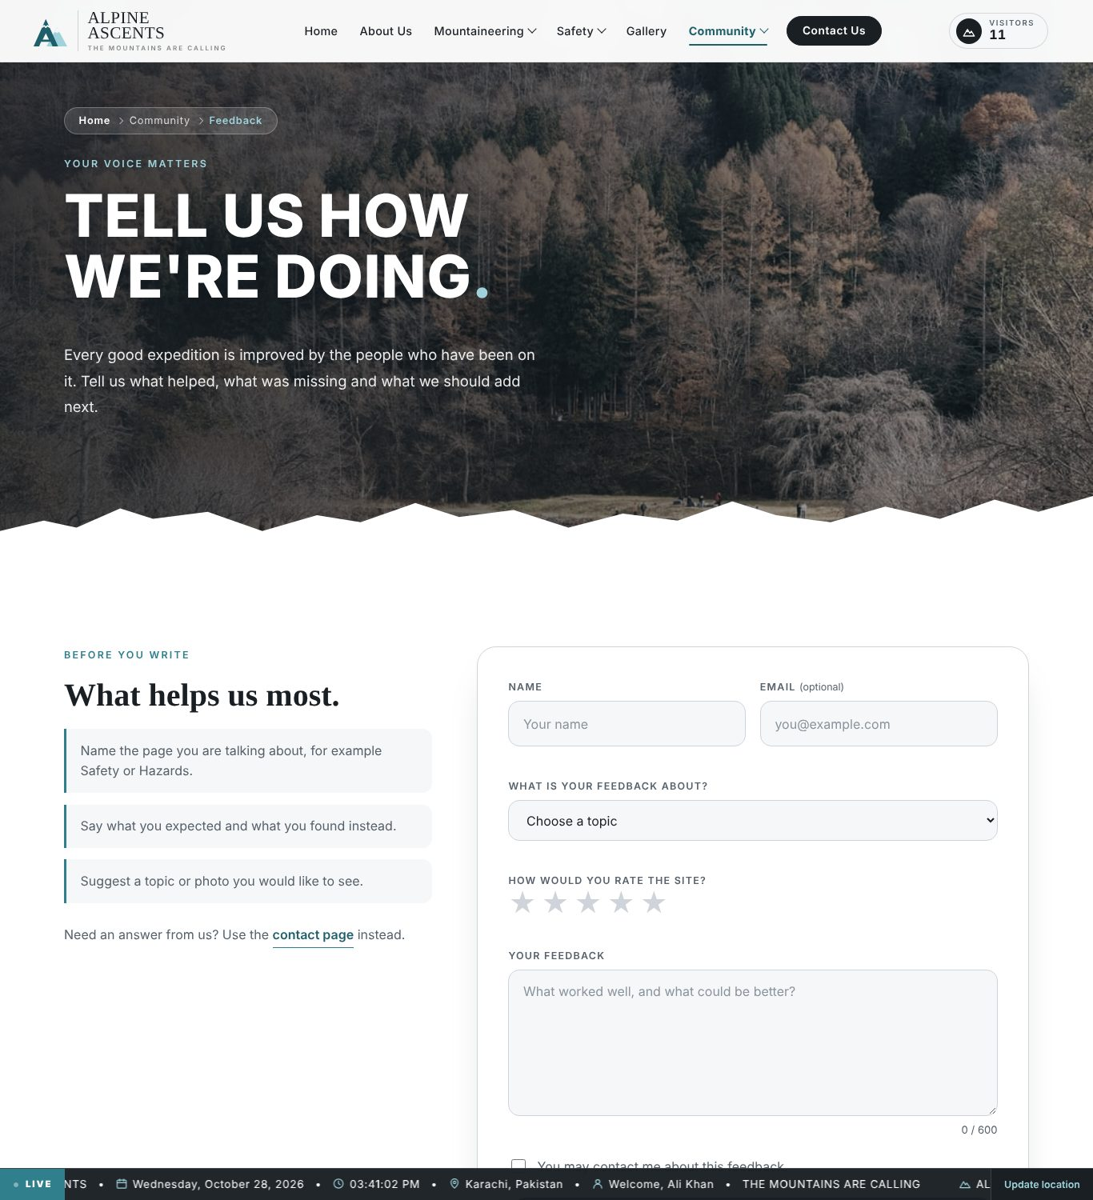
Figure 27: Feedback page
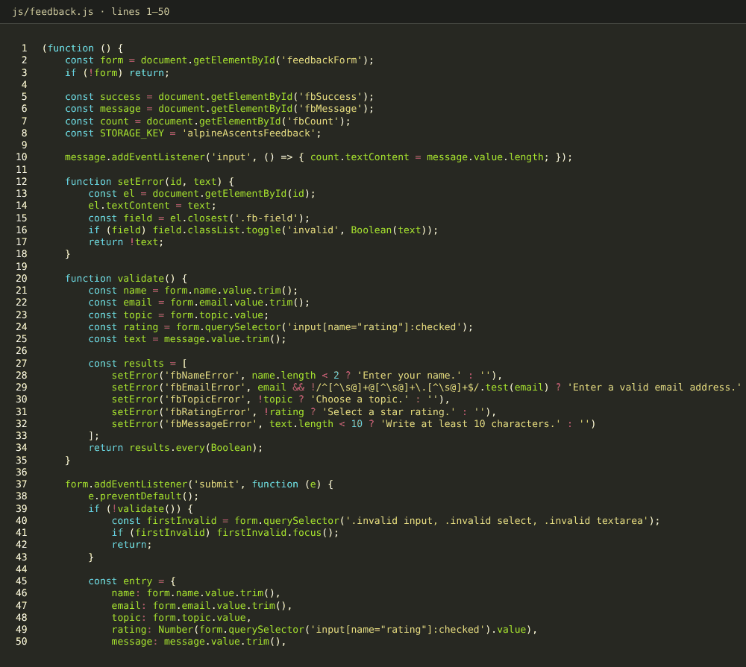
Figure 28: Source code: feedback.js (validation and saving)

9.14 Contact Us
Files: html/contact us.html, css/contact us.css, js/contact us.js. Contact cards, a form (name, location with a “Use my location” button, e-mail, phone, mountain of interest and message), a location section and four FAQ items built with details. Saved visitor details pre-fill the form. Entries are saved in aa_messages; no e-mail is sent.
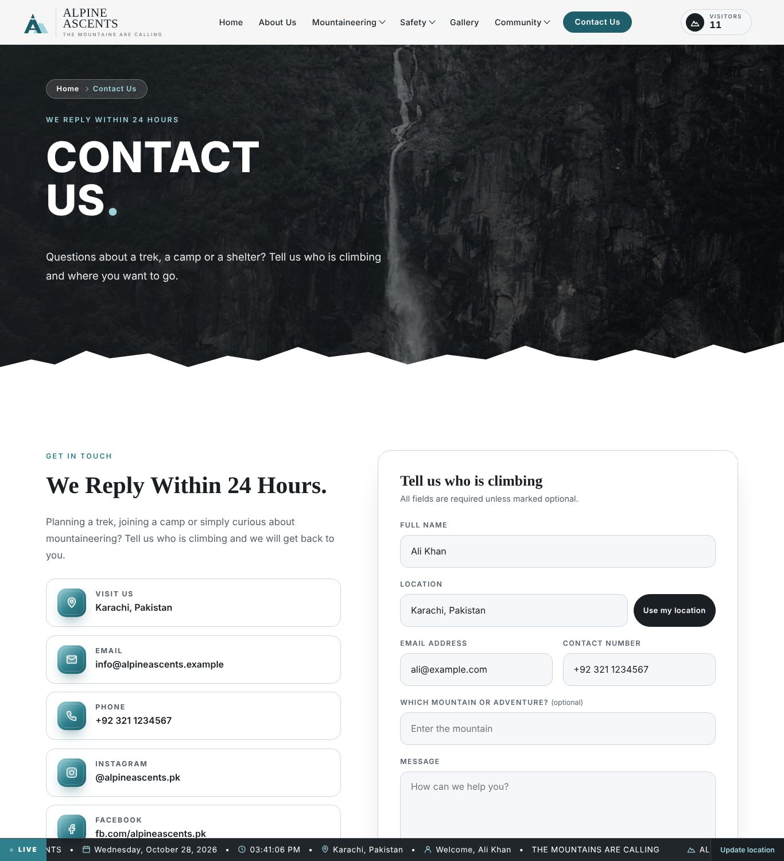
Figure 29: Contact Us page
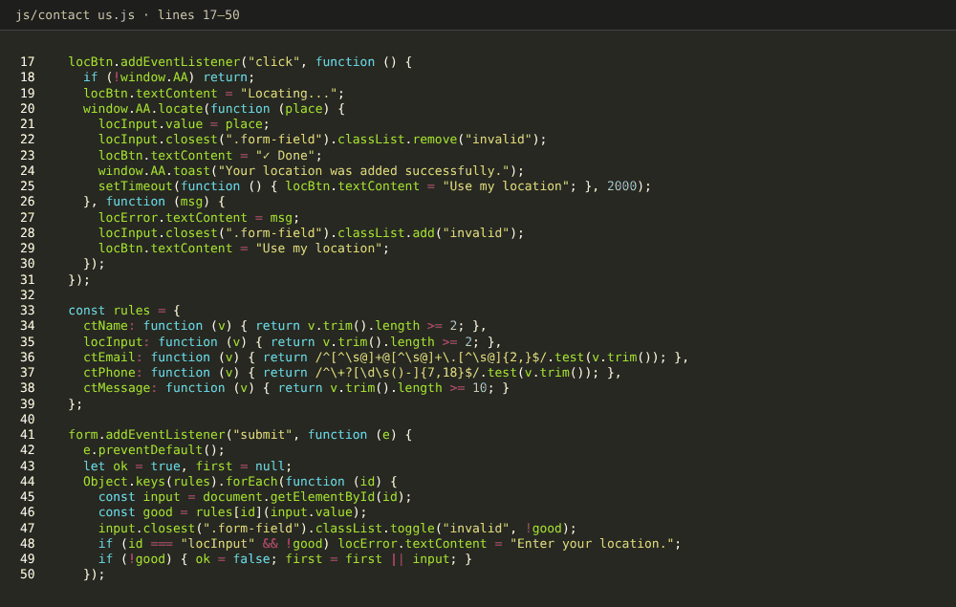
Figure 30: Source code: contact us.js (validation rules and saving)

10. Diagrams (Flowcharts and Data Flow)
In the flowcharts, rounded boxes show the start and end, rectangles show actions, parallelograms show input and diamonds show decisions. In the data flow diagrams, circles are processes, cylinders are data stores and parallelograms are external entities.

10.1 User Navigation Flowchart
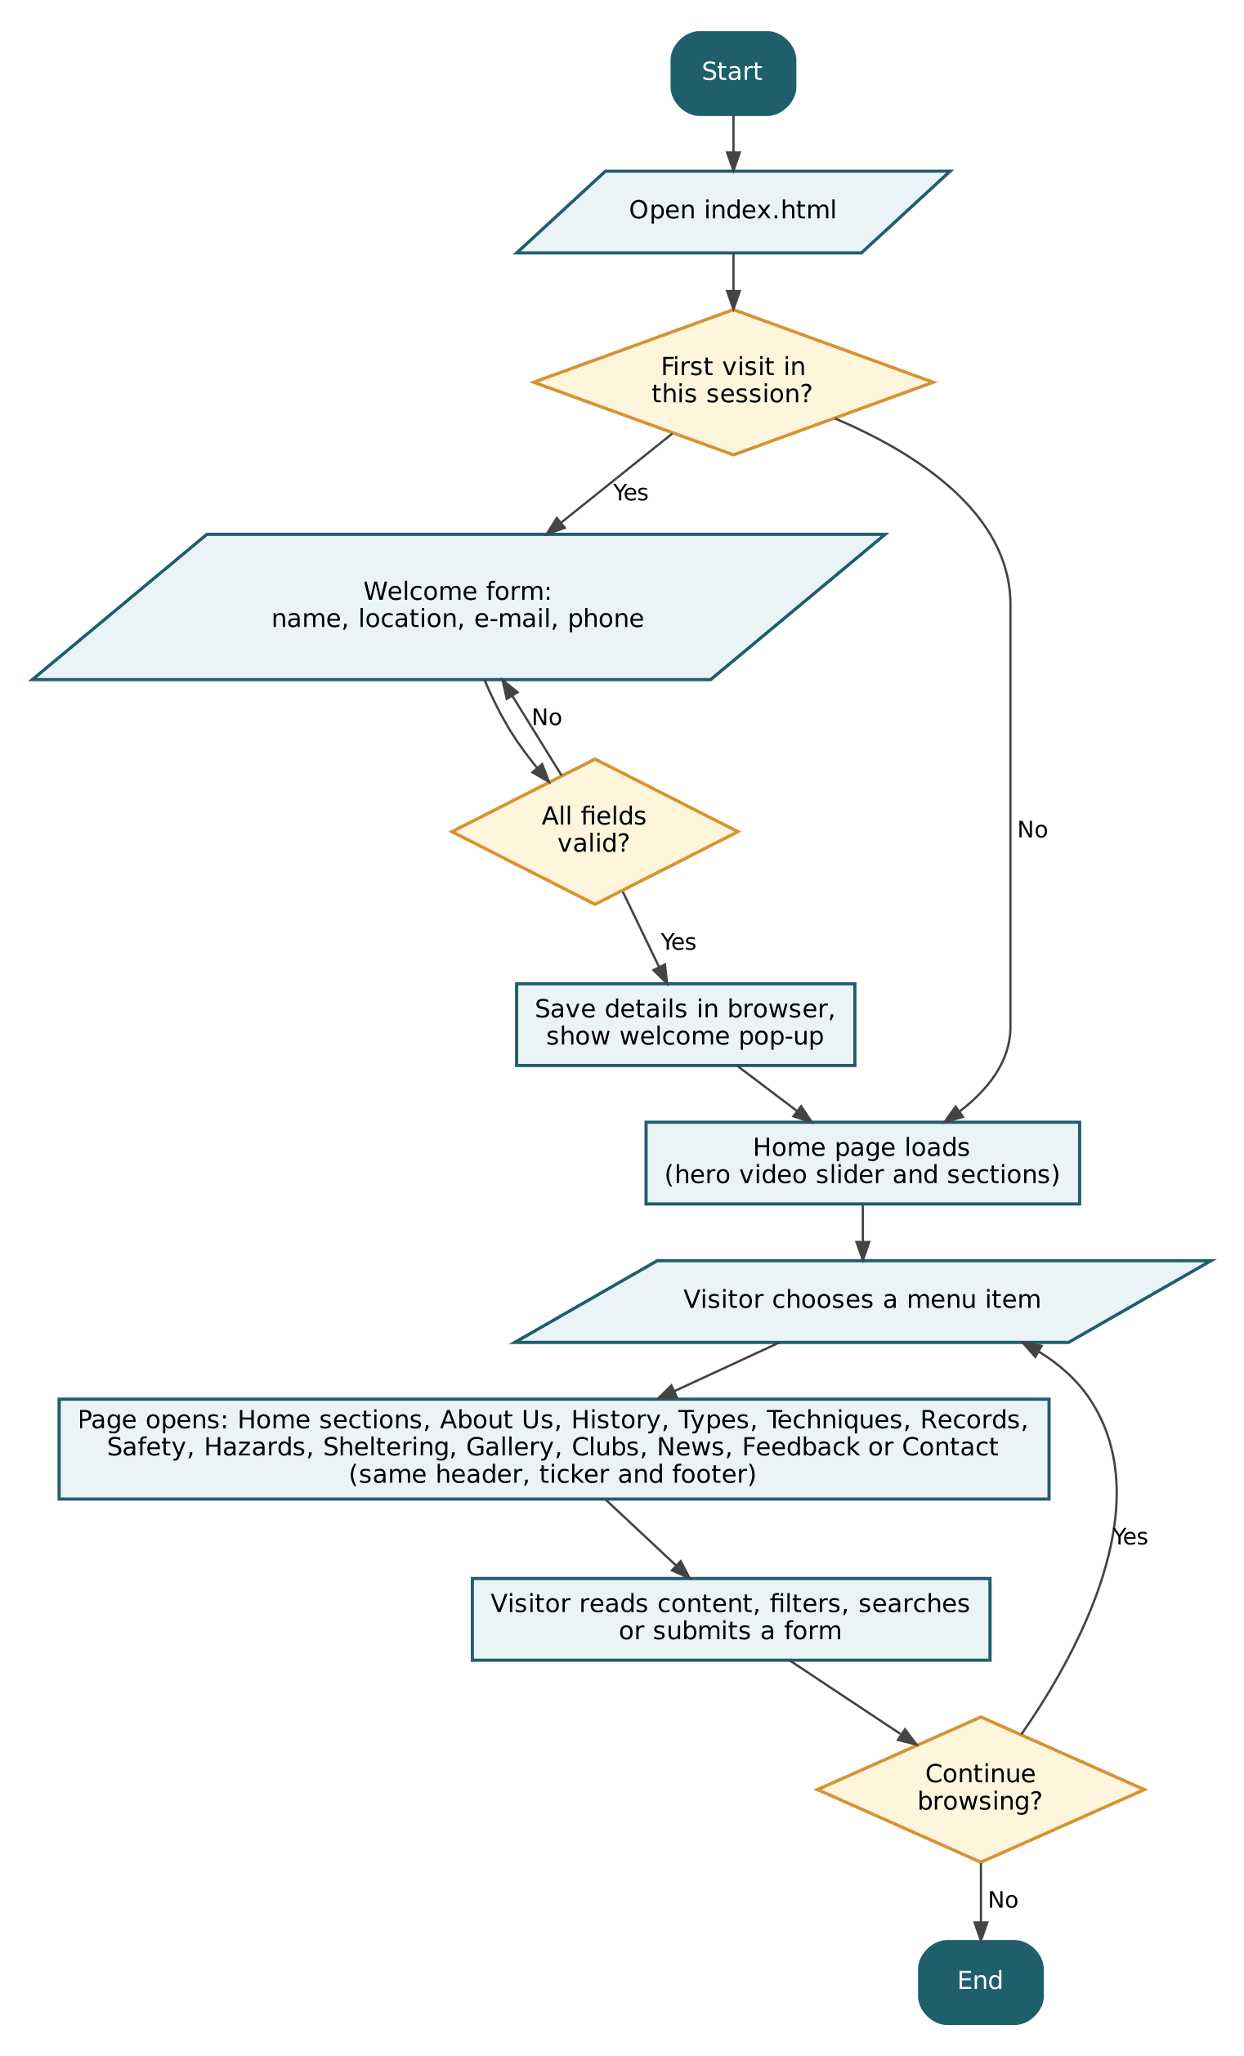
Figure 31: Flowchart: overall user navigation

10.2 Share Location Flowchart
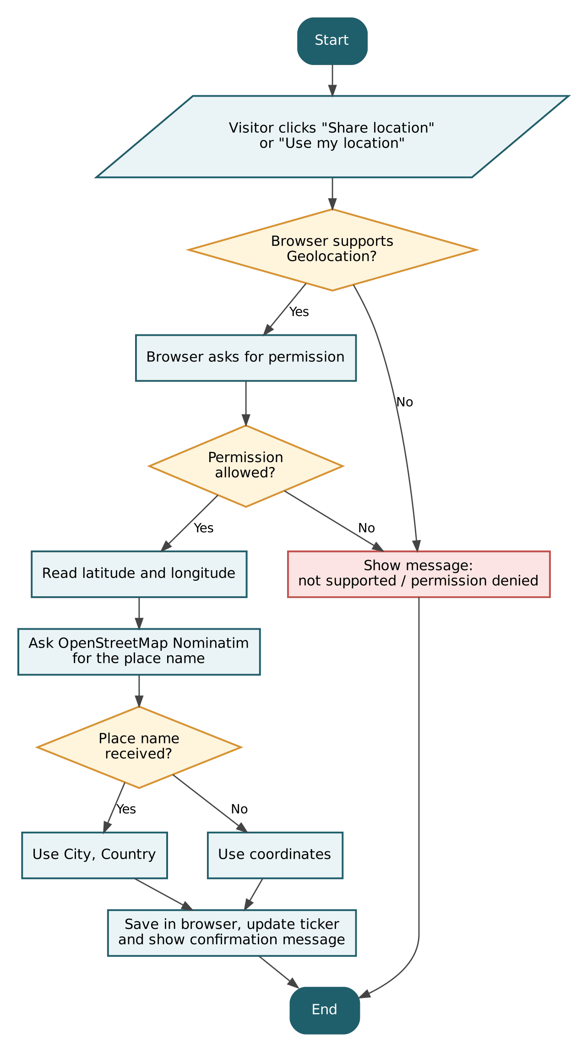
Figure 32: Flowchart: Share location and Use my location

10.3 Form Validation Flowchart
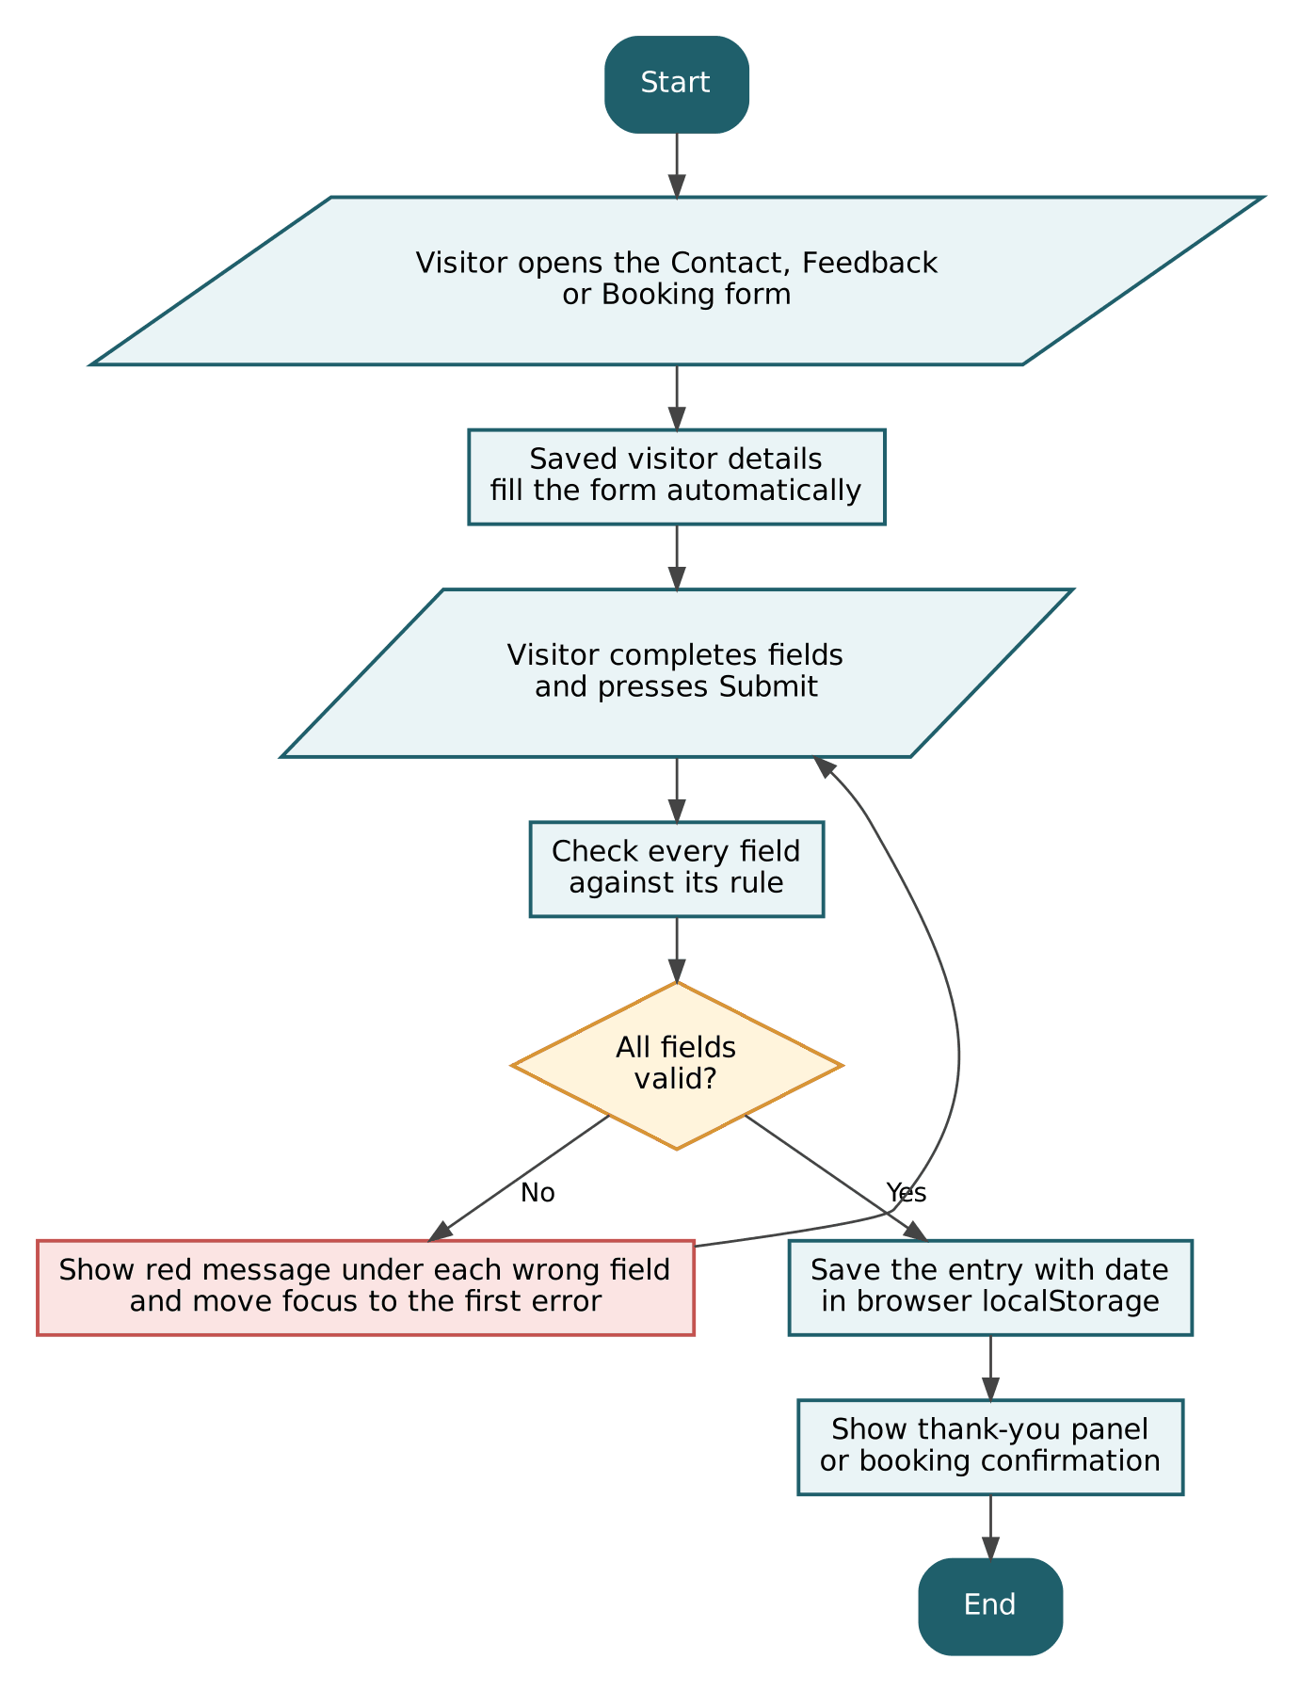
Figure 33: Flowchart: validating and saving contact, feedback and booking forms

10.4 Data Flow Diagram: Level 0
The context diagram shows the website as one process. The visitor sends page requests and form entries and receives pages and confirmations. The website reads its content from static files, saves visitor data in the browser storage and asks the Geolocation API and Nominatim for the visitor’s place.
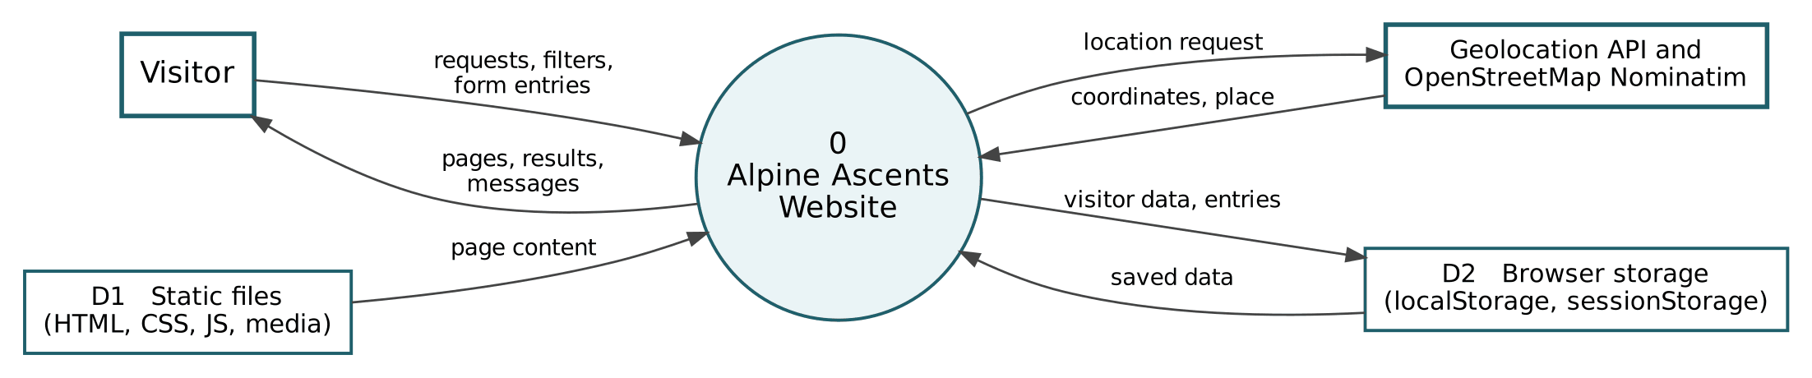
Figure 34: Data Flow Diagram, Level 0 (context diagram)

10.5 Data Flow Diagram: Level 1
Level 1 splits the website into five processes: render the page and navigation (1.0), welcome and visitor details (2.0), filter, search and explore content (3.0), validate forms and save entries (4.0) and locate the visitor and show the ticker (5.0). The website has no server database: D1 holds the static files and D2 is the browser storage.
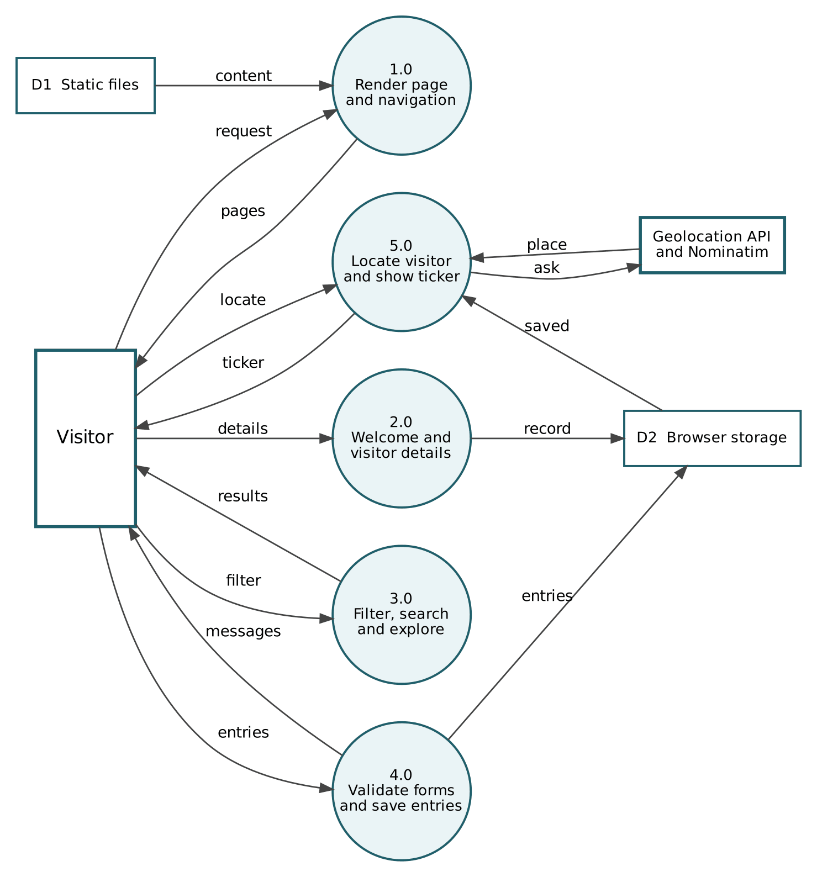
Figure 35: Data Flow Diagram, Level 1

11. Future Scope
- Add a backend (Node.js or PHP) with a database for real user accounts, a shared visitor counter and saved contact messages, feedback and bookings.
- Send contact and feedback entries by e-mail and connect shelter bookings to real availability and online payment.
- Integrate live weather and avalanche data for popular peaks.
- Add an interactive trek planner and difficulty filters.
- Provide multilingual support, including Urdu.
- Add a site-wide search feature and a dark and light mode switch.
- Convert the site into a Progressive Web App for offline reading and host all photos and videos locally.
- Improve performance with image compression (WebP or AVIF), more lazy loading and a CDN.

12. Conclusion
Alpine Ascents shows how a complete, professional and responsive website can be built using only HTML, CSS and JavaScript. The project achieved its goals of presenting mountaineering knowledge clearly, keeping a consistent theme, and adding useful interactive features such as the welcome form, video hero, live ticker, Geolocation support, searchable and sortable content, a clubs map and validated forms that keep their data in the browser.
Working on it strengthened our skills in front-end development, responsive design, accessibility and teamwork. The modular structure of the code, with one shared script and a small stylesheet and script for every page, makes the site easy to maintain and ready for future improvements such as a backend and database.

